The Making of an “Omnivorous Generation”*

Jennifer C. Lena
Columbia University, Teachers College

Omar Lizardo
University of Notre Dame

Keywords: Omnivorousness, generation, culture, valorization, vernacular, folk, institutions, New Deal, Progressive Era, museums, organizations

Word Count: 14,468 (plus 1,560 in Appendix)

*Earlier versions of this paper were presented at the 2014 Annual Meetings of the American Sociological Association in San Francisco, and at the 2015 Annual Meetings of the American Sociological Association in Chicago. We would like to thank Peter Bearman, Shamus Khan, Adam Reich, Wendy Griswold, and four anonymous reviewers for helpful comments and suggestions. Direct correspondence to Jennifer Lena, 525 West 120th St. Box 78, NYC, NY 10027, Email: jcl42@columbia.edu or Omar Lizardo, 810 Flanner Hall Notre Dame, IN 46556, Email: olizardo@nd.edu.
Abstract
We argue that the “historicality” embedded in cohorts is a key driver of contemporaneous patterns of cultural choice linking cultural production and consumption dynamics. We use data from the Survey for Public Participation in the Arts to examine this issue for the case of arts participation in the U.S. Our analysis uncovers a distinct “omnivorous generation” born in the post-Progressive Era. An historical analysis reveals that institutional entrepreneurship by government arts administrators increased the diversity of art on offer to this generation and was thus a primary contributor in generating durable dispositions, still evident today, towards cultural engagement among persons who came of age during this period.

1.0 Introduction
A fundamental premise of classic work linking the production and consumption of culture is that historical changes in the institutional organization of artistic production, dissemination, and classification are linked to the “making” of distinct culture consuming publics (Bourdieu 1993; DiMaggio 1982; Levine 1988; Weber 1977). In spite of this foundational emphasis on between-domain linkages, recent work in cultural sociology has been characterized by an increasing segregation of research on production and consumption dynamics. On the production side, we have sophisticated studies of the emergence, consolidation, and transformation of production systems and associated cultural classification regimes for cultural goods (Baumann 2001; Allen and Lincoln 2004; Ferguson 1998; Johnston and Baumann 2007; Lena 2012; Lopes 2002; Rossman 2012). On the consumption side, attention has centered on putative transformations of elite consumption patterns summarized by the notion of “omnivorousness” (Peterson 2005). This refers to the now well-established propensity on the part of contemporary elites to express a variety of cultural preferences and activities either within a single domain such as music or television (Lizardo and Skiles 2009; García-Álvarez, Katz-Gerro, and López-Sintas 2007) or, as in the analysis that follows, across the performing arts broadly defined (López-Sintas and Katz-Gerro 2005; DiMaggio and Mukhtar 2004).
If the major drawback of production-oriented studies is that they tend to leave implicit the consequences of production-side dynamics for patterns of cultural choice, a key weakness of consumption-oriented studies is that they tend to neglect the generative mechanisms for the genesis and maintenance of cultural tastes (Lizardo and Skiles 2012). As a result, there has been a relative lack of attention to the macro/micro linkage between institutional context and culture consumption patterns. In particular, work on the production of culture, save for some signal exceptions (e.g. Mears 2011; Lena 2012; Ocejo 2014), has lacked systematic examination to how the making of taste publics (Gans 1999) is contingent on processes embedded in configurations of institutional and organizational practices, themselves the product of specific historical trajectories. More specifically, there has been a relative dearth of work empirically examining how differences in patterns of artistic engagement may be reflective of the “historicality” encoded in individuals as a result of their distinct generational experiences (Abbott 2016). From this perspective, the differential distribution of culture consumption propensities at any given time may be the result of “institutional legacy” effects linking contemporaneous differentiation in cultural engagement to historical factors operative at previous point in time (Fishman and Lizardo 2013).
In this paper, we synthesize variegated lines of work pointing to linkages between production and consumption domains and institutional legacies embedded in unique cohort experiences (Abbott 2016; Greve and Rao 2014; Fishman and Lizardo 2013). Our argument is that historically durable dispositions towards “omnivorous” forms of arts consumption emerged for persons who experienced significant expansions in the availability, accessibility, and institutional valorization of categories of cultural goods (DiMaggio 2000). We demonstrate that there exists an empirically specifiable generational effect on the breadth of involvement in particular arts activities for specific groups of Americans. This is a contemporary behavioral pattern that can be traced to significant (e.g. “coming of age”) experiences, namely, institutional entrepreneurship within and around arts organizations during the New Deal, itself spurred by then unprecedented levels of public investment in American art. Our analysis thus provides a sustained empirical demonstration of the historically mediated effect of organizational practices and institutional legacies on patterns of cultural choice over time.

1.1 Outline of the Argument
We begin by empirically considering the possibility that there are exist specifiable generational signatures in the culture consumption behavior of Americans such that cohorts who experienced significant transformations in the volume and diversity of available culture are more likely enact “omnivorous” patterns of cultural engagement (López-Sintas and Katz-Gerro 2005). In keeping with the reliance of omnivorousness studies on the Survey of Public Participation in the Arts (SPPA), we examine patterns of reported attendance at eight “core” activities (DiMaggio and Mukhtar 2004). We use the cumulative data file covering six waves of the SPPA (SPPS 1982-2012) to empirically establish the existence of an “omnivorous generation:” a cohort of persons who were born between 1930 and 1950, came of age roughly between 1945 and 1969, and are likely to have relatively high levels of engagement across all eight activities.
We make sense of this empirical pattern via an historical analysis documenting the exposure of this cohort to a novel (especially in relation to their immediate predecessors) set of experiences in and around the (American) arts. We show how cultural capitalists in New Deal arts agencies engaged in institutional entrepreneurship promoting the artistic valorization of a wide variety of newly certified forms of “vernacular” art. We then examine the consequences of organizational support for artistic production and dissemination provided by federal, state, and local governments in the New Deal era. This support promoted an institutional shift in the treatment of domestically produced culture and this diffused across the country over subsequent decades.
In revealing the process by which an entire generation of Americans became relatively avid consumers of the arts, we are able to illuminate some of the organizational and institutional transformations that contributed to the rise of this taste public. In showing that such dispositions carry over into contemporary differences in the culture consumption behavior of Americans via historical encoding, we demonstrate that events that occur in the past can have significant consequences in the present (Abbott 2016: 10). Demonstrating the processes linking institutional dynamics in the field of cultural production at a previous point in time, to the contemporary structure of the field of cultural consumption, is our primary contribution.

2.0 Generations and Taste Publics
The concept of generations, as classically defined by Mannheim (1952), refers to age cohorts that experience the same major events in their lives and subsequently develop similar dispositions and worldviews (Ryder 1965). Mannheim’s generational thesis has been applied to empirical material mainly in the study of collective memory (e.g. Schuman and Scott 1989), and knowledge of important public events (e.g. Schuman and Corning 2000). We argue that this theoretical lens can be used to identify culture consumption generations whose dispositions are shaped by historically located organizational features and institutional processes.
Here we heed recent calls for cultural sociologists to move beyond an emphasis on contemporaneous socio-demographic effects on patterns of cultural choice and towards a more concerted consideration of temporality at both the individual and macrosocial levels. The increasing availability of data on repeated cross-sections of culture consumers has opened up this analytic potential, especially when it comes to the “omnivore thesis” (Reeves 2015: 116-117; López-Sintas and Katz-Gerro 2005). We see an opportunity to conjoin this line of work with recent calls to consider the “historicality” encoded in groups via their dispositions as a powerful historical force, thereby linking the institutional past with the behavioral present (Abbott 2016: 10; Greve and Rao 2014; Fishman and Lizardo 2013). Investigation of the features of omnivorous cultural consumption may serve as an ideal testbed for this process, as periods of intensive investment in the arts are often accompanied by the valorization of novel aesthetic objects; persons who came of age during these periods may “carry over” such dispositions to their engagement with art over time.

2.1 Previous Work on Generational Shifts in Omnivorousness in the U.S.
The American cultural omnivore was introduced in Peterson and Simkus’s (1992) analysis of elites’ musical preferences, although earlier qualitative studies suggested it would be found (cf. Lynes 1954; Shils 1958; Lamont 1992). Recent studies have predominantly relied upon the SPPA’s data on cultural participation and taste, demonstrated a particular interest in music as a site of taste discrimination, and relied upon certain data reduction strategies. Peterson and Simkus collapsed ten music genre response categories into three: highbrow, middlebrow, and lowbrow. To be counted as an omnivore, the respondent had to express a preference for both highbrow genres (classical music and opera), in addition to at least one other middle- or low-brow style. However, as Peterson and Rossman (2008) later argued, this measure binds the breadth of taste with the imputed social status of a style; consequently, both the narrow taste of the classical music, opera, and jazz fan, and the broad taste of the “all of the above” listener, are included among the omnivores.
An alternative operationalization of omnivorousness counted the number of genre preferences for each respondent and labeled them omnivores if they fell above some (arbitrary) count threshold, while another specification treated omnivorousness as a continuous variable in regression analyses (Rossman and Peterson 2015; for a review, see Peterson 2005). Still others subjected reports of attendance at cultural events to Multiple Correspondence Analysis, producing continuous dimensions that allow researchers to identify the most central and distal tastes, the latter of which are defined as “highbrow” activities (Lopes-Sintas and Katz-Gerro 2005). Later works also distinguished omnivorousness, or breadth of taste, from frequency of engagement, or “voraciousness” (Katz-Gerro and Sullivan 2005).
Initial interpretations of the omnivorousness phenomenon in the U.S. as comprising a categorical transformation in the cultural dispositions of elites have recently given way to more nuanced considerations of historical specificity and complex temporal dynamics. For instance, in the U.S., Rossman and Peterson (2015) show that by 2002 the proportion of the population that could be classified as “highbrow omnivores,” using Peterson and Kern’s (1996) definition, had receded to the same level as 1982, and remained low in the next (2008) survey wave. These results suggest that the trend towards greater omnivorousness reported by Peterson and Kern (1996) is not linear, and may have possibly reversed in younger cohorts. This effect may be a function of cohort replacement as older, more omnivorous cohorts are exiting via mortality. This points toward the possible existence of a generation-specific effect such that the conditions that generated omnivorousness in the older cohorts have dissipated, making younger respondents less omnivorous than their parents. Rossman and Peterson’s (2015) account is consistent with the possibility, to be explored more fully below, that there exists an identifiable (and bounded) “omnivorous generation” in the U.S., rather than a unilinear trend affecting the population at large.
This possibility is consistent with López-Sintas and Katz-Gerro’s (2005) results, based on behavioral rather than taste-based indicators of the omnivorous disposition, and taken from three waves (1982, 1992, 2002) of the SPPA. They note that, rather than observing an unilinear trend in which less omnivorous cohorts are replaced by more omnivorous ones, the “omnivorousness trend developed unevenly over the 20 years” and is characterized by period-specific effects. This reflects the null relationship between cohort and omnivorousness uncovered by Garcia-Alvarez, Katz-Gerro and López-Sintas (2007: 433). Taken together, this work points to the possibility of non-negligible generational patterning of omnivorousness in the U.S.
We analyze the same data source and behavioral indicators of engagement as López-Sintas and Katz-Gerro (2005), but augment the cumulative data set with the two most recent survey waves (2008 and 2012), while relying on a technique explicitly developed to tease out cohort from period and age effects in substantively meaningful ways (Yang and Land 2006, 2008; Reeves 2015).

2.2 Survey Data
We rely on the cumulative data file containing six waves of the the Survey of Public Participation in the Arts (SPPA), covering 30 years (1982-2012). The SPPA is sponsored by the Research Division of the National Endowment for the Arts (http://www.nea.gov), and is designed to capture Americans' participation in the performing, visual, and literary arts; it constitutes the largest recurring cross-sectional survey of adult arts participation in the U.S. The 1982, 1985, and 1992 surveys were conducted by the Bureau of the Census as a supplement to the National Crime Survey (NCS). The 1997 survey was conducted by Westat, a private contractor using a different sampling scheme, so it was not included as part of the cumulative data file. The 2002, 2008, and 2012 surveys were conducted by the Bureau of Labor Statistics as a supplement to the Current Population Survey. The SPPA 1982-2008 cumulative file was produced to facilitate trend analysis such as the one that we report here.
The SPPA is appropriate for our purpose for several reasons. First, these data have been used to establish a good portion of the research on omnivorousness in the U.S.; in order to provide an alternative explanation of this phenomenon we utilize the same data source. In keeping with current trends in the field, our operationalization makes use of all the key cultural consumption items in the SPPA and captures breadth and intensity of engagement. While these eight items reflect only a portion of the cultural activities enjoyed by Americans (of any birth cohort), the SPPA constitutes the largest recurring cross-sectional survey of adults arts participation in the U.S., and is thus the most likely to contain traces of continuity and differentiation in the long historical experience encoded in cohorts, information that is critical to our argument.
The SPPA items include genres with stable canons that enjoy generations of fans (classical, ballet, opera). They also include genres with dynamic content, many active sub-genres, and which enjoyed recent artistic legitimation efforts (jazz, musical). As DiMaggio and Mukhtar (2004: 175) note, these activities can be differentiated by levels of prestige and length of time at which they have been institutionalized as “serious art” (e.g. by being included in university curricula or by drawing revenue outside of commercial establishments): “with classical music, museum art, opera, and ballet at the top, followed by...jazz and musical theatre, and finally art...craft fairs” and finally historical sites “institutionally orthogonal but aimed at a broad audience.” Any discovery of the enabling effect of cohort membership on engagement across these activities would provide strong evidence for generational effects on omnivorousness.
The bulk of studies have focused on the effect of individual level characteristics (even if they have cohort signatures--like education) as predictors of broad and vigorous cultural engagement. Our analytic approach breaks with previous work in conceptualizing omnivorousness as a group-level phenomenon with potential generational signatures. Accordingly, we treat these repeated cross-sections as interlinked “cohort panels” data since they should preserve whatever continuities in generation-specific aesthetic dispositions are tapped by the core items covered in the cumulative file (Abbott 2016: 9). Our goal is to explore the possibility of effects on individual cultural engagement traceable to each person’s membership in cohorts of art consumers. In what follows, our aim is to ascertain whether we can speak of an “omnivorous generation” with breadth of engagement being predicated as a distinctive feature at that level of analysis.
This data source does have its limitations. For instance, the only way to establish over-time comparability is to fix the category labels for cultural activities. This introduces some artificial homogeneity into the analysis, since it ignores the historically dynamic nature of the artistic categories themselves (Lopes 2002; Lena 2012). However, the dynamic nature of these categories is less worrisome if we assume that more or less the same disposition towards aesthetic consumption can be transposed to new contexts (Lizardo and Skiles 2012). The fact that the SPPA can only report whether a particular person reports preferences or activities at any point in time, but does not reveal the way that this category is engemented (e.g. the “how” of consumption), is a more significant limitation, although it is one that this study shares with all other survey-based work on the subject.

2.3 Outcome: Arts Participation in “Core” Activities
Our goal is to ascertain the possible existence of generational (cohort) effects in engagement with the arts; given the existence of these effects, our goal is to identify their pattern. The SPPA tracks arts participation by, among other things, asking respondents about whether they have engaged in a series of activities during the last 12 months. Consistent with previous work (e.g. DiMaggio and Mukhtar 2004; López-Sintas and Katz-Gerro 2005), we focus on the SPPA’s ‘‘core’’ items: questions about attendance at classical music concerts, jazz performances, opera, musical theatre, ballet, visual art exhibits at museums or galleries, arts and craft fairs, and historic sites. Respondents choose either “yes” or “no,” with residual codes for “don’t know” and “refused.”
Table 1 shows the percentage of respondents who reported having attended each activity for all six survey waves. The table also reports the number of respondents for whom we have non-missing data on each item in each year. We fit logistic regression models to each separately.

[Table 1 About Here]

2.4 Statistical Model
Though simple conceptually, the estimation of cohort (generational) effects is not a straightforward exercise. The issue is the identification problem posed by the deterministic relationship between age, period, and cohort, as any one of the three factors is a linear combination of the other two (e.g., period = cohort + age; cohort = period - age; age = period - cohort); these three pieces of information are really only two pieces of information. This makes it impossible to separate the three effects in an unambiguous way within the context of a regression model. There are no magical solutions to this problem and no assumption-free ways of solving it. Yang and Land (2006) have proposed an approach that makes reasonable assumptions, grounded in a sociological conceptualization of the underlying substantive meaning of cohorts and periods as contextual groupings of persons defined by a common event and experiences (Ryder 1965).
Substantively, Yang and Land’s (2006) hierarchical age-period-cohort (HAPC) approach to breaking the linear dependency between age, period, and cohort relies on conceiving of age as an individual characteristic that is specific to each sampled respondent. Consistent with our goal of uncovering omnivorous generations, an individual’s assignment to a given cohort (and period) is specified as a contextual effect within a multilevel modelling framework. The partially overlapping nature of cohort and period memberships implies that, in the context of a repeated cross-sections survey design (such as the cumulative SPPA), time periods are not fully nested within cohorts or vice versa (as in standard multilevel models in which persons are embedded within fully overlapping contexts such as schools and neighborhoods). Rather, one obtains a “cross-classified” structure with individuals nested within cells defined by birth cohorts and time period.
Statistically, this yields the Cross-Classified Random Effects Models (CCREM; see Yang and Land 2006, 2008 for technical details). The cohort effect thus captures that which is distinctive of each generation and is carried forward via historical encoding; period effects capture purely contemporaneous influences, while age is held constant as an individual level trait. Accordingly, we specify a crossed random-effects model for binary outcomes of the general form:
(1)
Where Y_{ijkl} = 1 if individual i, assigned to cohort group j, interviewed at survey wave k reports having attended the l^{th} arts participation activity; υ_{0j} is the random effect for the jth cohort group (at 5 year intervals), υ_{0k} is the random effect for k^{th} period group (survey year), age is the respondent’s age centered at (the grand mean of) 45 years, age² is the square of the respondent’s age, while ꞵ₁ and ꞵ₂ are fixed regression weights. The result of interest in this model will be an estimate of the age and period-adjusted likelihood of the group level (cohort) effect for each arts participation activity. Positive (negative) deviations from the expected baseline (represented by the sign of exp(υ_{0j})) are taken as evidence of a facilitating (suppressing) effect of cohort group membership on arts participation for the l^{th} activity net of period and age influences.
It is important to underscore that the goal of this analysis is to isolate and establish the existence of generational effects on arts participation and to chart their distribution across cohort groups. Our use of these statistical models is not meant to be “explanatory” in the sense in which this term is sometimes misused in variables oriented analysis, but descriptive (Spillman 2014). Our strategy is to deploy this statistical framework to establish a broad, empirical pattern of generational effects on arts participation rates. The existence of this effect, as well as its specific patterning, become the phenomena to be further elucidated. The goal is to then link cohorts distinguished by higher than expected participation rates to unique institutional experiences, using a complementary case-based methodological strategy that combines historical narrative, institutional analysis, and process-tracing (Schneiberg and Clemens 2006; Fishman and Lizardo 2013).

2.5 Hierarchical Age-Period-Cohort Model Results
While the HAPC models produce fixed effects estimates of the effects of age on cultural participation (𝛽₁ and 𝛽₂ in equation 1), of more substantive interest are the random variance component estimates for the cohort (𝜐_{0j}) and period (𝜐_{0k}) group contexts for each outcome. These are shown in Table 2. These estimates give us a sense of whether we can identify cohort and period based on variation in art participation levels, above and beyond the effect of age. Not surprisingly, we find statistically significant cohort and period-based variance for all outcomes. Comparing the substantive magnitude cohort and period variance component estimates across participation outcomes, we can see that the cohort effect rivals the period effect in size for all outcomes except Ballet attendance. For three outcomes (Jazz, Classical, Musicals, and Art Museums) the cohort-based variance is substantially larger than the period-based variance; in the case of Art Festivals both are of equal (substantively significant) magnitude.

[Table 2 About Here]

[Table 3 About Here]

[Figure 1 About Here]

To get a sense of the magnitude of the cohort effect, we create an index (θ_{j}) for each five-year cohort group comparing the expected probability of participation for each cohort group when the cohort effect is set to its estimate from the HAPC model, and the expected probability of participation for those same individuals assuming that the cohort effect is zero, with the difference normalized with reference to the overall expected probability taking both period and cohort into account.

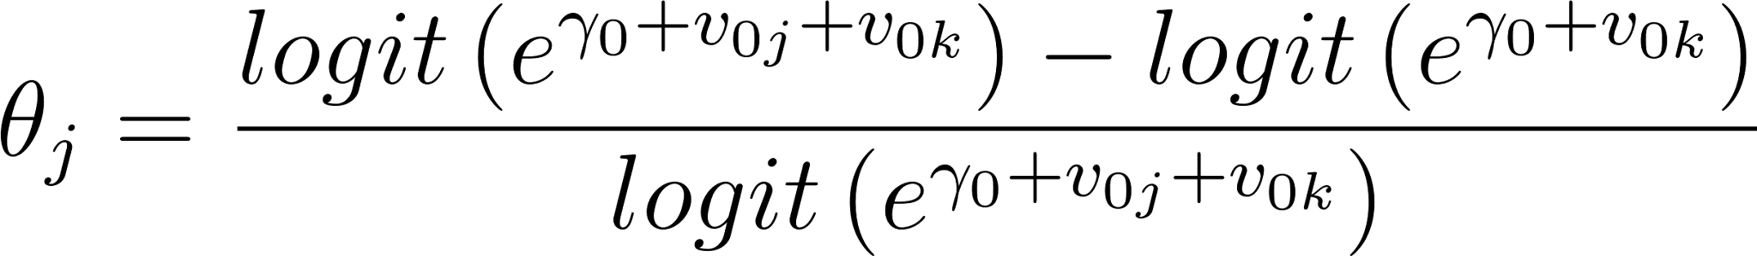 (2)

This gives us a substantively interpretable quantity: the percentage increase (decrease) in the probability of participation that is attributable to the group-level (generational) effect. This allows comparison between activities with very different baseline participation rates such as Opera (relatively unpopular) and Art Festival attendance (relatively popular), and for which the absolute generational effect is larger and smaller respectively (DiMaggio and Mukhtar 2004). This cohort effect index can be interpreted as a deviation (in percentages) from the expected likelihood of participation for each individual if we were to ignore the generational influence. Numbers above zero indicate that a member of that cohort is more likely to be culturally active than expected, given that person’s age and the year in which they took the survey. Numbers below zero indicate that membership in the cohort depresses cultural participation in comparison to baseline expectations. Numbers close to zero indicate that members of that cohort participate at close to the expected rate for that age group and in that survey year.
The cohort effect estimates (θ_{j}) for each activity across all 21 cohort groups and for all eight SPPA core activities are shown in Table 3. Given the fact that the reader is being asked to keep track of 168 quantities, and to facilitate visual inspection of the overall pattern of results, cells in which the θ_{j} > 10% are shaded in blue, while cells in which θ_{j} < 10% are shaded in red. The rest of the cells (e.g. θ_{j} ≦|10|) are shaded in gray, we also present a visual representation of these results in Figure 1.
The direction and magnitude of the cohort effects across different participation rates reveal a clear pattern of generational clustering. Across putatively distinct arts-participation practices, we find that, with few exceptions, cohorts born between 1930 and 1950 have higher positive deviations in expected engagement than their earlier born counterparts. Because the distribution of age becomes truncated as we move to more recently born cohorts (or move back to the earliest cohorts), we are more cautious about interpreting the negative cohort deviations at the extreme boundaries (e.g. 1890-1900 and 1980 to 1990). We can say, however, that the concentration of substantively significant positive deviations within a narrow band of cohort groups born within a span of three decades does sanction the designation of these generations as (comparatively) “omnivorous.”
For instance, a person born between 1940 and 1944 is about 36% more likely than expected to have attended a Jazz concert in the year before they completed the survey, 39% more likely to have attended the Symphony, and 22% more likely to have gone to an Arts Festival. A person born between 1945 and 1949 is about 12% more likely than expected to report having attended the Ballet, 26% more likely to have gone to an Art Museum, and 22% more likely to have gone to a Historical Park or Monument. As indicated by the red and gray shaded cells surrounding members of the 1930 - 1950 generational cluster, cohorts born before and after are characterized by either a lower or close to baseline likelihood of participating in each activity. This underscores the distinctiveness of the relatively avid participation rates of the omnivorous generation in relation to their predecessors and, to a lesser extent, their immediate descendants.
The observed generational clustering of positive deviations is even more remarkable since, with some small exceptions (e.g., Ballet for persons born between 1930 and 1934 and Musicals for persons born between 1945 and 1954) it extends across the entire range of forms of arts participation tracked by the SPPA, including those legitimated in the nineteenth century (such as Symphonies and Art Museums), those that were more recently legitimated (Jazz), and those that have never been the subject of explicit, elite-led legitimation campaigns (Musicals). In addition, the generational clustering pattern encompasses practices with relatively wide appeal (such as Craft Fairs and Art Festivals), and practices in which only a small minority of the population claims to participation at any one time (see Table 1). That the omnivorous generation reports their enjoyment of both old and new culture, and styles that are both dynamic and stable, provides additional support for our argument.
Figure 1 provides a plots the distribution of effects shown in the Table (on the y-axis) across 5-year cohort groups (on the x-axis) for each cultural activity ordered by level of popularity (from top-left to bottom right), providing a visual summary of the overall pattern of results. This figure confirms what we have already seen in Table 2. Save for a few exceptions (e.g.,attendance at Symphonies for those born between 1910 and 1920), the biggest positive cohort deviations are found among persons born between 1930 and mid-century.

2.6 Summary of Survey-Based Analysis of Cohort Effects in Arts Participation
Results from random-effects Hierarchical Age-Period-Cohort Models (HAPC) point to the existence of a distinct omnivorous generation, born in the immediate post-Progressive Era, who are more likely to engage in diverse forms of arts participation. For this group of respondents, the generational effect is facilitative rather than inhibitive, and extends to virtually all of the core arts participation activities. For most activities, the generational effect is bounded roughly between 1930 and 1950. This produces a consistent “reverse U-shaped” cohort effect for all of our outcomes (see Figure 1 for the pattern of cohort deviations and Figure 4 in Appendix 1 for predicted rates of participation).
As detailed in the supplementary analyses reported in the Appendix, these results are robust to alternative (fixed effects) specifications of the HAPC modelling strategy (section 1, figure 4); moreover (section 2, figure 5), the cohort boundaries suggested by the HAPC analysis, especially those separating the omnivorous generation from their predecessors, can be corroborated by inspection of simple cohort-by-period graphical plots (Reeves 2015; see e.g. Voas and Chaves 2016 for an application of this approach to religiosity trends). Finally (section 3, figure 6), there is suggestive evidence that members of this generational cluster are more likely to report more exposure to the arts when growing than persons born before 1930.
Overall, these results strongly suggest that persons born in the three decades immediately following the Progressive Era are distinctive enough in their pattern of cultural engagement to be considered an “omnivorous generation.” As noted above, it is important underscore both the avidity and breadth of cultural engagement of members of this generation. This breadth extends to forms of folk and vernacular culture that were legitimized during the 20th century, including Jazz and--most importantly for our argument--Craft Fairs and Art Festivals. These results lead us to discard interpretations of omnivorousness as a linear cohort trend over time, in favor of a generational specificity argument (Rossman and Peterson 2015; López-Sintas and Katz-Gerro 2005).
The pattern of generational clustering is in itself a compelling finding but as a macro-level quantitative pattern it opens up questions that the survey data alone cannot answer (Spillman 2014). What exactly makes the generation born in the immediate post-Progressive Era distinctive from those born just a decade earlier? A generational clustering pattern of this sort suggests we should find an historically rooted transformation related to artistic classification, dissemination, and production systems (DiMaggio 1987, 2000). We will show that this generational effect can be traced to the expansion and consolidation of elite-led institutional work enacted during the Progressive Era, which consolidated in powerful organizations during the post-war period. These left their mark in the “encoding” of individual cultural consumption practices, and made this generation distinct from their predecessors.

3.0 Institutional and Organizational Impacts on Taste Publics
Deep and fruitful investigations of cultural tastes on the one hand, and the production of culture on the other, provide contemporary scholars with the opportunity to build more sophisticated accounts of the links between these two cultural realms. We begin with a simple premise: historical changes in the institutional organization of culture are linked to the creation, maintenance, or dissolution of culture consuming publics. This sensitizes us to look for this type of antecedent to account for the omnivorous generation.

3.1 The Emergence of High Culture as an Exemplar Case
In an influential article, DiMaggio (1982) attributes the emergence of a distinction between high and popular culture in the U.S. to organizational and institutional transformations that took place in 19th century Boston. This is the period when the grand project of defining an institutional field of “fine arts” culture began to be pursued by bourgeois, urban elites. This is also the period in which what Levine (1988: 85-168) has referred to as the “sacralization” of the arts began in full force. These fields come to have an organizational base in universities, museums, galleries and other elite-supported non-profit institutions designed for the production, dissemination, and canonization of cultural products; they play a critical role training both artists and consumers in the newly defined principles of cultural valuation (Conner 2008: 113; DiMaggio 2000).
This research demonstrates an association between organizational factors (the creation and elaboration of the non-profit arts organization) and institutional work (sacralization) accomplished by cultural entrepreneurs (the Boston Brahmins; college educated arts bureaucrats) resulting in the production and perpetuation of a new form of taste (“high culture”). It is this sort of work that is still needed as sociologists explore new forms of cultural expression, and new production arrangements. These include, most importantly for our purposes, the characteristic features of the 20th century’s artistic field: the emergence of omnivorous culture consuming publics and aesthetic valorization processes leading to the expansion of the artistic canon. Although scholars have proffered some scattered ideas on the link between these two developments, no single analysis has tried to link the behavioral manifestation with its institutional antecedents.

3.2 Artistic Valorization Processes
Once the non-profit organizational form provided elite art patrons dominion over definitions of “art,” they turned their attention toward maintaining the new category’s legitimacy by responding to shifting expectations of the role of art at the national level. Changing political, social, and economic conditions during the interwar period placed pressure on organizations to modify their institutional practices. In particular, arts administrators, dealers, experts, critics, patrons, donors, collectors, artists, and audience members sought to change definitions of “American art” to reflect perceived transformations in the national character: “one of the consequences is that...museums welcome into their halls works that were not considered Art until they were granted entry: African ‘primitive’ works, folk art, comic strips, and even industrial artifacts” (Zolberg 1984: 390). The artistic valorization of vernacular and popular culture--and what Bourdieu (1965) called les arts moyennes--was the locus of intense institutional entrepreneurship in the first half of the twentieth century, and is the focus of our interest.
Studies of artistic valorization document transformations in which works are selected for presentation in benchmark organizations, and the consequent legitimation, or “aestheticization,” of the genres into which those works are classified. Notable studies of artistic valorization have been completed on jazz (Lopes 2002; Peterson 2005), rap (Lena and Pachucki 2013), film (Baumann 2001), rock (Regev 2007; Schmutz 2005), and cuisine (Ferguson 1998; Johnston and Baumann 2007). These studies reveal that artistic valorization is promoted by cultural capitalists, institutional entrepreneurs who possess varied forms of symbolic capital that give them the power to re-define artistic classification systems and to situate their tastes in privileged positions (Bourdieu 1987, 1993, 1996). When structural transformations threaten the exclusivity of elite tastes, they can use their familiarity with, and training in, artistic classification to appropriate new works into legitimate categories. Peterson and Kern (1996: 905) argued that as “aesthetic entrepreneurs...propounded avant gardist theories that placed positive value on seeking new and ever more exotic modes of expression…[these] expressions of all sorts from around the world [were] open to aesthetic appropriation.”

3.3 The Artistic Valorization of Folk Culture in 20th Century America
A defining feature of the post-Depression years is the striving of cultural capitalists to expand the artistic canon via the aesthetic valorization of vernacular culture. Scholars have identified many societal antecedents for this period of transformation, including the “emergence of an inclusive national culture, linking local economies, identities, and lifestyles” (Hall 1984); the occlusion of administrative control of the arts from an essentially hereditary, urban elite by a large class of upwardly-mobile college graduates (DiMaggio 2000); the subsequent managerial revolution in the arts (Zolberg 1986; Meyer 1979; DiMaggio 1991, 2000); the expansion of art education, advocacy, and trade union and guild solidarity by artists (McDonald 1969: 345); and the expansion of public, foundation, and corporate support for the arts (Zolberg 1981, 1986; DiMaggio 2000).
The last of these--particularly, federal and state government support for the arts during the New Deal--played a signal role in the artistic valorization of multiple art forms. Under the auspices of the New Deal programs, federal, state, and local government bodies provided subsidies to individual artists and supported new schools of art, visual art spaces, and performing arts events. As a direct commissioning agent, government bodies encouraged the production of works that displayed “the American experience” and its “roots in the folk tradition of the people” (Matthews 1975: 334). Administrators of WPA offices encouraged their artists to develop “a local vernacular associated with regional and cultural identity…[a] vernacular of authenticity that could plumb native sources of modern art within an academic tradition, the vernacular of folk art, the vernacular of indigenous traditions and ethnography, the vernacular of the everyday, and the vernacular of regional artists, photographers, and filmmakers giving expression to national consciousness during the lean years of the Great Depression” (Umbach and Hüppauf 2005: 25). Broad-based transformations in the expectations of the art-consuming public resulted from these measures, and arts administrators, curators, and artistic directors worked expeditiously to make that culture available. In so doing, they valorized some vernacular culture, heralding the rise of what some have called a renaissance of “vernacular modernism” (Bacon 2005).

3.4 The WPA: Overview of Agencies and Output
The activities of the New Deal era arts agencies softened elites to the expansion of the American arts to include forms of vernacular or folk culture. The presentation of these works in benchmark arts organizations made it possible for culture consumption publics to treat (some) “lowbrow” cultural forms as legitimate carriers of cultural capital. In this section, we examine the practices of New Deal arts administrators paying particular attention to the production of “vernacular modernist” works and their endorsement by cultural capitalists. Their display and performance in benchmark arts organizations, and subsequent valorization of these works as art, shaped the historical context within which the most omnivorous generation of American art consumers came of age. The adoption of these works by elite art advocates, and concurrent and subsequent efforts on behalf of other culture fields (jazz, film), provide the omnivorous generation with organizational and institutional context to support their broad and avid arts participation.
Facing massive unemployment and poverty, President Franklin Delano Roosevelt established federal agencies charged with employing out-of-work artists and with achieving a “picture of democratic justice and spiritual beauty” (Biddle 1939: 267-8, quoted in Mathews 1975). This phrase comes from the memoir of lawyer-turned-artist George Biddle, prep school friend of Roosevelt, and the man often credited with suggesting an artist’s work relief program as part of a more comprehensive plan to provide citizens’ assistance in the wake of the Great Depression.
State-level support for indigent artists began as early as 1931, but the first Federal, non-relief project for artists, the Public Works of Art Project, was initiated in 1933. This program, with the Treasury Relief Art Project (1935-9), awarded commissions to artists for the production of paintings, sculptures, and murals for display in federal buildings across the nation. A more comprehensive work relief program was announced in August, 1935 and was known as the Works Progress Administration (WPA). Under the WPA, the four programs referred to as “Federal Project Number One” provided subsidies for the production of visual art, music, theater, and literature (and later, the historical records survey).
Artists employed under Federal One produced a great variety of artworks, including paintings, graphics, motion pictures, murals, photographs, posters, sculptures, and plates for the Index of American Design. Still others taught art and art appreciation; mounted exhibitions, tours, and lectures; built frames and dioramas; and sketched maps. Some creative workers even developed color standards and tested paint in cooperation with the Bureau of Standards.
The resulting output of creative material is nothing short of astonishing: from 1935 to its closure in June 1943, artists created 2,566 murals, 17,744 sculptures, 108,099 paintings, 250,000 prints from 11,285 images, 2 million posters from 35,000 designs, and more than 22,000 design plates (O’Connor 1969: 28-9; Greengard et al 1986: 58-60). As one historian opined: “the resulting output of Americana was overwhelming” (Mathews 1975: 334). The Federal Writers’ Project paid creators of books, poetry, pamphlets, leaflets, and radio scripts including socio-ethnic studies; expositions on industrial, labor, society, and community issues; and documents of American and Native American folklore. The Federal Music Project produced a similarly massive array of works including over 1,500 compositions by 540 American composers, performed by symphony orchestras, small orchestral ensembles, string quartets, chamber music ensembles, and operatic and light opera concert ensembles; grand opera, light opera, and chamber opera companies; vocal ensembles and vocal soloists; and dance orchestras, bands, and theater orchestras (Federal Works Agency 1947: 64). Estimates of the total cost of the WPA hover around $35 million.
New Deal elites like Harry Hopkins, appointed in 1933 to direct monies for actors and musicians, endorsed the vision of a cultural democracy taken up by Roosevelt. Hopkins pushed theater directors to depict the deplorable conditions in tenements in the hope that they might encourage a landslide of support for the construction of decent housing for American citizens. The Theater Division commissioned adaptations of non-theatrical material like pageants, dance dramas, and living newspapers in order to dramatize the full range of American life. Playwright Percy MacKaye called for a “Drama for Democracy” and theaters that would be a “civic agency” for “the whole people” (N.A. 1936, “Art: Government Inspiration”). The Farm Security Administration sent writers and photographers into the Dust Bowl states to document the lives of the people there and to demonstrate “the need for government programs and their benefits” (Greengard et al 1986: 58-60).
This progressive vision of a democratic republic was anchored by a commitment to documenting, preserving, and aestheticizing the cultural production of immigrants, non-whites, and “untrained” creators. Artist Yasuo Kuniyoshi has argued that great American art was collected and created by WPA “artists [who] were encouraged to prove the American experience and search for roots in the folk tradition of the people, documenting the values and behavior of a culture in the throes of self-recognition” (Matthews 1975: 334). Musicologist Charles Seeger was encouraged by the Resettlement Administration to foster the unity of communities by encouraging the use of indigenous musical resources. Seeger had built his career on identifying regional, popular, and folk music and integrating those with academic music into a uniquely American idiomatic expression (Mathews 1975). WPA music division director Nikolai Sokoloff presented folk music of a dizzying variety: white and black spirituals, Spanish songs from the Southwest, Creole ballads from Louisiana, liturgical music from California missions, and bayou songs from the Mississippi delta (Mathews 1975: 336). In 1936, Time Magazine reported that Sokoloff’s payroll included a 22-piece “gypsy orchestra” in Pittsburg, a Hungarian ensemble in Chicago, and típica orchestras in San Antonio and Tucson (N.A. 1936, “Music: Relief Melodies,” 1936). The Writer’s Project sent reporters into every state to collect what Ben Botkin, director of the Folklore division, called “living lore,” including the testimony of European immigrants and former slaves.
Federal One produced a nearly encyclopedic rendering of vernacular, folk, and “minority” art, and presented it to the public as a manifestation of great American art. The humble origins of much of this cultural material in some cases stood in contrast to the pageantry and even glamor of its display. Operating under the aegis of federal, state, and local governments, some of these works were presented in benchmark arts organizations including the Smithsonian, the National Gallery, the Museum of Modern Art, and the Federal Art Gallery in New York (Greengard et al 1986). The Public Works of Art Project closed with a gigantic exhibition in Washington at which high-ranking government employees were encouraged to take what they liked and to display the art in their offices. President and Mrs. Roosevelt hosted a series of nine concerts of “traditional” musicians at the White House, including one in June 1939 attended by the King and Queen of England, the first reigning British monarchs to visit the U.S. The playbill included the mountain string band the Coon Creek Girls; Marion Anderson, the contralto opera singer; the North Carolina Spiritual Singers; and musicologist Alan Lomax, who performed cowboy songs.
Federal One programs hosted programming in elite spaces but the provision of cultural programs in non-urban spaces was more consistent with its mission: “The introduction of urban amenities, both material and cultural, into rural America was one of the basic purposes of the New Deal, and manifested itself in the arts no less than in rural electrification” (McDonald 1969: 185). Since professionally-trained artists were less likely to live or wish to travel to non-urban spaces, Federal One, like the other relief programs, primarily employed unskilled labor (McDonald 1969). If the ambition for the culture programs was the development of the fine arts--as it certainly was for some administrators--it was tempered by federal requirements for work relief. Unskilled laborers often worked within folk art traditions, having, in many cases, little formal training or interest in the fine arts--and so much of the work produced under Federal One was produced by amateurs. This commitment to amateur folk culture production was even more profound once the WPA was abolished by Congress in June, 1939, and these projects were transferred to the states (McDonald 1969: 320-1).
Many local, state, and federal arts organizations ended up in possession of the works created under Federal One, and they formed the core of their 20th century collections. For example, the original 22,000 plates from the Index of American Design are housed at the National Gallery of Art in Washington, DC. Von Groschwitz, Supervisor of the Graphic Art Division of the Federal Art Project in New York, claims that 134 color lithographs made by WPA artists were acquired by museums and remain in their permanent collections to this day. The Newark Museum also has a large number of WPA-sponsored works, including Minna Citron’s painting, “Staten Island Ferry.” Yet, many other works produced in the New Deal era were destroyed, abandoned, or forgotten.
Other federal offices shifted their commissioning practices to provide ongoing support for working artists; McDonald (1969: 62 f ☨) noted that “one of the immediate and permanent effects of the PWAP was the establishment...of a Painting and Sculpture Section in the Procurement Division of the Treasury. This section was...given charge of the decoration of federal buildings…. Previously, the responsibility of such decoration had been that of the architect who received the commission.”
Administrators of federal repositories of visual artworks facilitated their display around the world, lending them to World’s Fairs, museums, galleries, and consulates. The Smithsonian, and its Traveling Exhibition Series, was particularly active in circulating WPA-produced works, and pursuing the larger goal of presenting American democracy as manifest in vernacular modernism. They initiated the Festival of American Folklife in 1967, and the estimated million people who attend each year makes it the largest annual cultural event held in the U.S. capitol (N.A. 2013, “Smithsonian”). Its programming is a near-mirror of the New Deal art initiatives: combining song, dance, craft, and workshops, the festival is organized to feature nations, states, and regions, and to highlight the vernacular culture of these places.
The New Deal agencies enacted a comprehensive program to produce and support art by ethnic and racial minorities, and the poor. They also provided an opportunity for the public to consume vernacular or folk art as a form of moral engagement with their nation and communities. The omnivorous generation thus came of age at a time when the production and presentation of art was “central” to a federal relief project, and forms of folk art enjoyed such support. The WPA created opportunities for cultural capitalists to sacralize a new, more diverse group of works as art, and an organizational context within which to do so. The omnivorous generation may have carried forward preferences for consuming some of the art that they were exposed to as they came of age, an open disposition to a broad range of cultural forms, or both (see section 2 of the appendix for corroborating evidence for this claim). Former New Deal arts administrators and their peers carried the work of aesthetic valorization forward, securing the transformation of arts organizations and institutions that had begun in the Progressive Era. As the omnivorous generation aged into adulthood and older age, they create historical continuity between this extraordinary period of institutional transformation and expansion and the present. This is manifested primarily in the enduring proclivity to engage the arts more than members of older generations. Remarkably, the encoded historical memories of the omnivorous generation continue to be forceful even during a period---beginning in the late 1970s---of increasing retraction and devolution of government support for the arts.

3.5 Aesthetic Entrepreneurship
New Deal era arts administrators transformed the institutional practices of benchmark arts organizations so that folk material could be included in their collections and repertoires. Among them was Holger Cahill, Director of the Federal Art Project (FAP) (1935-1943), who influenced the curatorial directions of several institutions including the Newark Museum and MoMA, where he served as interim director for a year (1932-1933). He filled in for his frequent collaborator Alfred H. Barr, the first Director of MoMA (1929-1943), and in this post both were concerned with canonizing material that drew upon the nation’s unique folk traditions, a modernist project for which MoMA would become famous. They were joined by Edith Halpert, an art dealer who co-founded New York City’s first folk art gallery (the American Folk Art Gallery) with Cahill in 1929. All three (Halpert, Cahill, and Barr) had close relationships with Abby Aldrich Rockefeller and worked with her to build her large and influential collection of both modern and folk art (Bacon 2005).
Barr was succeeded as the Director of MoMA by another advocate of folk art and alum of the New Deal arts agencies. Formerly Manager of the WPA’s Indian Arts and Crafts Board, René d'Harnoncourt was an established expert in Mexican, vernacular, and modern American art. During his tenure at MoMA (1949-1968), d’Harnoncourt supervised and curated numerous exhibitions of folk art from the U.S. and elsewhere including displays of “African Negro Sculpture” (1952), American woodcuts (1952), toys (1953), “young American printmakers” (1954), animated cartoons, paintings by “amateurs” (1955), graffiti (1956), film posters (1960), and “Japanese vernacular graphics” (1961). He became a close advisor to Nelson A. Rockefeller, Abby Rockefeller's son, and supported Nelson’s acquisition of an enormous collection of so-called “primitive art” from Africa, Oceania, and the Americas. It was d'Harnoncourt who encouraged the budding philanthropist to establish a museum to display his collection. Rockefeller opened the Museum of Primitive Art in 1957; it housed the nation's most extensive collection of art objects from Africa, Oceania, and the Americas until it closed in 1976. Rockefeller's primitive art collection was then transferred to the Metropolitan Museum of Art (NYC), signaling a shift in the museum’s opinion of these works, and their adoption or recognition of this work as art (LaGamma et al 2014). Equally significant changes were taking place in the performing arts, as cultural capitalists moved benchmark arts organizations toward the goal of preserving and protecting a distinctly American vernacular modernism.
The significance of this move toward vernacular modernism, and the expansion of art historical canons to include the works of folk and minority artists, can also be seen in the creation of new organizations and institutions throughout the United States. These include the American Folklife Preservation Act of 1976, the American Folklife Center, the Folk Arts Program at the National Endowment of the Arts, and UNESCO’s 2003 International Convention on the Safeguarding of Intangible Cultural Heritage (Kurin 1989: 18-19).
Many creative communities have benefited from the expansion of the canon to include folk and vernacular forms of culture. Cinema, jazz and rock music, graffiti, and weaving and textiles (especially quilting) are a few of the many forms of creative expression legitimated in the 20th century, each of which benefited from the institutional and organizational transformations that began in the Progressive Era (McDonald 1969: 343-4). Thus, we see a plumb line from the WPA arts programs to the present in the role of benchmark arts organizations, the Federal government, and a small group of cultural capitalists in documenting, preserving, and displaying American folk culture. The governors of these organizations and events contributed to the growth of new arts institutions and organizations. Progressive Era elites legitimated a form of folk American culture, and a generation of Americans were exposed to it in public and private spaces across the country. The WPA art projects fostered two tendencies that are critical to our argument: “a greater awareness of art on the part of the American people, and a greater awareness of America on the part of the American artist” (McDonald 1969: 341).

3.6 Supplementary Analysis
Given our argument, it is instructive to compare generational differences across consumption domains that differ both by (a) levels of differentiation across social strata and (b) the likelihood of being an institutional conduit for the aesthetic valorization of American folk culture. Out of the eight SPPA core participation activities, attendance at Art Museums and Craft Fairs and Art Festivals provide such a substantively motivated contrast (DiMaggio and Mukhtar 2004; López-Sintas and Katz-Gerro 2005). If our argument is on the right track, we should find sharper cohort differentiation patterns setting apart the omnivorous generation from other cohorts for Craft Fair and Art Festival attendance, since the latter was a locus of state-led institutional investment and a conduit of aesthetic valorization practices. In addition, we should find a relative lack of differentiation between persons who have garnered elite markers of status (e.g. a college degree) and those without in the generational effect for Craft Fairs and Art Festivals in comparison to Art Museum attendance.

[Figure 2 About Here]

[Figure 3 About Here]

Figures 2 and 3 show the results of cohort-specific participation likelihood estimates obtained from separate random-effects HAPC models estimated for persons without and with a college education (or more) for both participation in Art Festivals/Craft Fairs and Art Museum attendance (respectively). As before, the cohort effect is the deviation in the expected probability of participation in comparison to the cohort and group specific (college-educated versus non-college-educated) baseline rate. Since the effects are normalized to each group’s baseline, it is not appropriate to interpret these as absolute effects across groups but only as relative effects. For instance, stronger cohort effects for non-college educated individuals born in a particular cohort do not mean that the non-college educated are more likely to attend than the college educated (the absolute rate of attendance of college educated individuals is higher for all activities in all cohorts). Instead, it means that non-college educated persons born in that group have stronger deviations from the overall baseline expectation for the non-college educated than college educated people born during those years have in relation to their own college educated peers. Note, however, that even a proportionally “smaller” effect among the non-college educated may imply larger absolute effects, as the college educated are a comparative minority of the U.S. population, especially in the first half of the twentieth century.
The results of this analysis show the omnivorous generation effect crosses the education divide, and it illustrates the mediation of this generation’s arts engagement by artistic form and education. First, the generational effect is of a much stronger substantive magnitude for Art Festival/Craft Fair attendance than attendance at Art Museums. Second, there are education-based differences in the cohort effect: it is stronger for college educated persons born between 1930 and 1950. However, the difference within this cohort between those with college educations and those without is larger for Art Museums than it for Art Festivals. Third, we can observe positive cohort effects (in relation to generational peers without a college education) among non-college educated Americans born between 1915 and 1929 when it comes to participation in Art Festivals and Craft Fairs. This suggests that less educated Americans coming of age during the Progressive Era may have benefited from cultural activation mechanisms that did not depend on access to elite cultural capital from higher-education institutions (DiMaggio 2000). This is what we would expect if the WPA programs in fact facilitated the expansion of, and broadened access to, this domain of cultural enjoyment. Art Festivals and Craft Fairs are thus among the group of participatory activities that may have functioned as gateways into other forms of arts participation, like attendance at museums, as shown by the positive cohort effects on this outcome for non-college educated individuals born during the Progressive Era (Figure 3).

4.0 Discussion and Concluding Remarks

4.1 Epochal shifts versus Generations: Consequences for Omnivorousness Research
We have examined the consequences for cultural consumption of a transformation in the artistic classification system. This allows us to link institutional activity around the category of American art to historically enduring dispositions in the likelihood of different generational clusters to broadly engage the arts. In this way, the current research is of relevance to work on the sources of transformation in cultural taste (DiMaggio and Mukhtar 2004; López-Sintas and Katz-Gerro 2005; Garcia-Alvarez, López-Sintas and Katz-Gerro 2007; Johnston and Baumann 2007; Rossman and Peterson 2015). Our analysis advances the literature in demonstrating the analytic payoff of taking temporality seriously for the purpose of elucidating the mechanisms that generate cultural tastes (Reeves 2015). Unlike our peers, we focus on omnivorousness as a group-level phenomenon, demonstrating how the uptake of cultural goods previously marked as popular, vernacular, folk, or primitive culture by art publics is conditioned by historically specific processes of institutional change, institution building, and cultural expansion. In this way, our argument addresses a key issue raised by a small but growing chorus of voices clamoring to situate the omnivore taste phenomenon in a more encompassing macro-historical context, one attentive to case-specific historical trajectories (Johnston and Baumann 2007; Fishman and Lizardo 2013; Hanquinet, Roose and Savage 2014; Prieur and Savage 2013; Lizardo 2008; Wright 2011).
Some scholars have suggested that omnivorousness is an irreversible epochal shift toward more inclusive tastes--either only among elites, or as a broad cultural transformation toward cosmopolitanism (Regev 2007; Saito 2011; Prieur and Savage 2013). Some of these scholars intimate that this transformation can be traced to pervasive and powerful media presentations of global culture (Appadurai 1996; Kuipers and de Kloet 2009; Wright, Purhonen and Heikkilä 2013), the exhaustion of modernist aesthetic as a cultural force and the subsequent hegemony of consumer culture (Wright 2011; Hanquinet, Roose and Savage 2014), or increasing social and geographic mobility (Peterson and Kern 1996; Van Eijck 2001; Daenekindt and Roose 2014; Emmison 2003). Yet these scholars have not investigated the possibility that omnivorousness can function as a generational trait, even though group-level measurement of the phenomenon would be the ideal method to adjudicate these hypotheses.
We have shown that historically rooted institutional processes constituted a generation distinct in its relative openness to engagement across a wide set of artistic offerings. Our results thus point to the possibility that the accumulation of new tastes can be a group level phenomenon, emerging as a response to the dynamic expansion of the arts to include formerly vernacular or “middlebrow” fare, particularly after the mid-century. .Importantly, this implies that speaking of omnivorousness in terms that do not take into account the specific historical conditions under which clusters of individuals come of age has its limitations. Simply put, future research needs to consider the possibility that the current focus on individual-level omnivorousness masks variegated, partially overlapping institutional processes of artistic valorization, whose outcomes ripple through distinct generations of art consumers in historically uneven, temporally “lumpy” ways. Some scholars have begun to test the impact of macro- and meso-structural factors to explain the rise of omnivorousness, to mixed results. Such investigations typically fail to reveal variation in highbrow omnivores, and scholars then discard the explanatory role of contextual factors (e.g. Lambert et al 2005).
Our analysis does suggest that while attention to institutional, organizational, and state-led projects geared towards the expansion of the aesthetic canon is important, ultimately the “historicality” produced by these factors must ultimately be encoded in individuals to be causally effective (Abbott 2016). In addition, because individuals carry these encodings forward over their lifetime, the effects of institutional transformations go beyond their immediate (contemporaneous) influence. Instead, culture consumption behavior may exhibit consistent heterogeneity that is not fully traceable to current opportunities and constraints (“period effects”) but which instead need to be traced to generational legacy effects (Greve and Rao 2014). Most research in the field focuses on individual level stratification within generations, traceable to class, gender, or race. We argue that the existence of a generationally specific forms of avid engagement in the arts cannot be accounted for without understanding major institutional and organizational transformations during the Progressive Era. We may enhance our explanations of heterogeneity in cultural engagement (in the U.S., abroad, or cross-nationally) by linking structured differences to historical conditions of genesis rather than looking at more temporally proximate factors. This should be a focus of further research on the subject.

4.2 Contributions to Studies of Organizational and Institutional Change
We have argued that one cluster of influences on cultural participation can be found in the government programs that employed artists during the New Deal, the consequent expansion of benchmark arts canons that followed, and the artistic valorization of these folk idioms. These institutional changes contributed to the creation of a distinct generation of art consumers in the last quarter of the 20th century, one that displays intensive patterns of arts participation to this day. In this way, the present research adds to our understanding of the organizational and institutional foundations of the rise of taste publics. Our analysis shows that this sort of “institutional work” can have wide-ranging consequences, including the formation of enduring cultural dispositions among an entire generation of art consumers (DiMaggio 2000).
It is reasonable to expect that the legacy of institutional work enacted during the Progressive Era would carry forward, producing multiple subsequent generations of omnivores. Yet, our results (Table 3) indicate that the cohorts born after the mid-1950s have baseline or slightly below baseline likelihoods of consuming all eight cultural forms. While we have not focused here on the contrast between the omnivorous generation and younger cohorts, we do speculate that the long-run impact of these organizational and institutional changes on subsequent generations was uneven. While most additions to the canon remained, and the basic classification schema remained in place, the end of the New Deal heralded the gradual decline of other resources. Art schools closed, murals were over-painted, and federal cultural policy gradually turned toward providing relatively meagre levels of support for individual professional artists (and later, primarily organizations).
The constellation of factors that produced the omnivorous generation were only partially (and sometimes only weakly) present for their children. However, Americans born in the 1980s or thereafter may not yet have reached their peak years of cultural engagement and could, in thirty years time, reveal themselves to be members of a second omnivorous generation. There are other forms of cultural consumption which, if cross-sectional data were available, could permit us to identify a strong generational effect for younger Americans (e.g., comic books, music videos). In short, we can neither negate the power of these organizational and institutional changes to produce a generational effect among younger cohorts in subsequent waves of the SPPA, nor can we dismiss the possibility that other cultural items would reveal a generational pattern that is different from the one we have identified above.
Scholars have identified patterns of omnivorousness among individuals in many nations, and we recommend the application of our model to those data. The exogenous factors that gave birth to an omnivorous generation (e.g., economic depression, state and educational expansion) were felt around the world. We expect that the capacity and orientation of federal governments to respond to those conditions with cultural policy solutions varied greatly. The timing, scale, and focus of any such investment would impact the likelihood that generational effects would result, and would resemble those we have identified in the U.S. It is also possible that organizational and institutional transformations abroad could have resulted from isomorphic pressures exerted by changes in the U.S., without having grounding in any domestic work relief program.. Whether there are broad cross-national commonalities or synchronicities in the emergence and generational location of omnivorous expression should be left as an empirical question to be answered in each national setting.

4.4 Contributions to Comparative Cultural Policy Studies
The policy implications of both our argument and our findings are potentially quite significant, especially when thinking about the (intended and unintended) consequences of state support for the arts (DiMaggio and Useem 1978; Alexander 1996; Alexander and Rueschmeyer 2005). Our analysis suggests that government subventions to the arts, and institutional work around the aesthetic valorization of folk culture, can produce a generation of omnivores--highly engaged and broadly curious consumers--and a generation or more of creative innovators. The health and vitality of arts sectors thus depends on the existence of robust delivery systems which serve to expose incoming cohorts at the right (e.g. “coming of age”) moment in the life course. Young individuals, especially those outside of elite circles, may depend upon these delivery and exposure systems to engage the arts. The degradation of such systems via disinvestment, defunding, or retraction to class-segregated, privatized venues may result in permanent shocks including entire generations withdrawing from certain forms of cultural engagement. This is consistent with the long-standing claim that artistic producers are better off under high public support systems than market-dominated systems (Alexander and Rueschemeyer 2005).
Additionally, our results support the relatively under-explored thesis that broad, public engagement with the arts (the “demand side” of the equation) is highly dependent on how the arts are institutionally “framed” at the national level and that state action may have a lot do with this framing (Alexander 2008). Cohorts coming of age before the late 1950s were exposed to an environment in which the arts were portrayed as more class-differentiated, the supply of accessible works relatively scarcer, and the moral purpose of arts consumption less likely to be framed as serving “national” (as opposed to elite-centered) interests. It is possible that the consolidation and expansion of the avant garde art world in the major American urban centers, including New York City, Chicago and San Francisco (Crane 1989), coupled with the subsequent retrenchment in public support for the arts in the Reagan-Thatcher era, may have produced a generational reversal in engagement.
In conclusion, our results are consistent with comparative evidence (e.g. Virtanen 2003; Alexander and Rueschemeyer 2005): where public support for the arts is still relatively generous (e.g. Scandinavian social democracies), engagement with the arts is both more intense and less differentiated by such markers of status such as education. Our analysis suggests that the U.S. enjoyed such a “social democratic” historical moment, leaving a lasting impact on an omnivorous generation of art consumers, and facilitating a moment of great institutional change in which the artistic canon expanded our access to the real American character.

Appendix
As noted above, the age-period-cohort problem is ultimately one of perfect collinearity between three pieces of information, and there are no assumption-free ways of resolving that collinearity. The HAPC framework provides one way of tackling the issue while making reasonable, sociological assumptions (e.g. treating cohort and period clusters as overlapping “groups”). However, since we want to draw substantively meaningful empirical conclusions from this analysis, the reader may wonder how sensible such conclusions are to the assumptions embedded in the method. In this section we evaluate the robustness of the results presented earlier by ascertaining whether we can replicate the substantively similar differences between the cohort groups using alternative analytic strategies.

1.0 Fixed Effects HAPC Estimator
One way to check the robustness of the results is to examine their resilience when we relax a key assumption of the HAPC strategy: that the cohort and period “group” effects can be parsimoniously modelled as “random effects” (parametric deviations from an average effect assumed to follow a normal distribution with constant variance) rather than being specified directly (e.g. by entering vector dummy variables for each period and cohort group into the regression). As Yang and Land (2008) note, this latter “fixed effects” strategy is perfectly feasible, although they ultimately recommend the random-effects approach on the grounds of parsimony and computational efficiency. However, one possible drawback of the random-effects HAPC model is that certain results (e.g. large positive deviations for the 1930 to 1955 generations) may be produced by over-smoothing underlying non-linear cohort trends. Yang and Land (2008) thus recommend checking results from the two estimation strategies for consistency.

[Figure 4 About Here]

Estimates of cohort-specific levels of engagement (at 5-year intervals) estimated from the random-effects and fixed-effects estimation approaches are shown in Figure 3. As the Figure shows, both estimation strategies reveal a reverse “U” shaped cohort trend peaking between 1930 and 1950 for all eight core SPPA activities. Significantly, this analysis demonstrates that the HAPC approach actually underestimates the differences between the cohorts born between 1930 and 1950 especially when it comes to the key contrast with their older counterparts (successors). This is true for all activities except Jazz and Classical music concerts. This is indicated by the more pronounced “peak” in the fixed-effect, cohort-specific estimates in comparison to the random-effects estimates of culture consumption activity and the much lower fixed-effects predictions for those born before 1930. These differences are more pronounced for Musicals, Art Museums, Art Festivals, and Historic Monuments. As such, it is safe to say that the random-effects HAPC models revealed the presence of an omnivorous generation in spite of the fact that, in this particular application, they turned out to be a more conservative estimation strategy especially in “smoothing” the differences between the omnivorous generation and their immediate predecessors.

2.0 Corroborating Omnivorous Generation Boundaries via the Graphical Method
Another relatively simple (and thus undemanding of the data) strategy is the “graphical” approach for disaggregating period and cohort effects advocated by Reeves (2015) in the context of arts participation data. This is an approach Voas and Chaves (2016) follow when identifying cohort changes in religious participation in the U.S. Here, we use it to validate the criterion validity of the cohort boundaries delimiting the omnivorous generation.
The graphical approach consists of the visual inspection of plots with survey year on the x-axis and a given outcome on the y-axis, with separate lines (either theoretically or empirically determined) for cohort clusters. In Figure 5, we examine the probability of participation in the eight core activities for three 25-year cohort clusters: 1900 through 1925, 1930 through 1955 (the “omnivorous generation” according to the HAPC models), and 1960 through 1985. Note that no “estimation” is required here as these are descriptive plots, although the cohort cutoffs are derived from the HAPC estimates. The plots should be read as follows: any “horizontal” trends (e.g. upwards, downwards, flat, curvilinear) indicate the (cohort-specific) period effect; any “vertical” differences indicate a cohort effect net of period (e.g. a line standing atop another one indicates a positive effect for the first cohort).

[Figure 5 About Here]

These results provide strong support for the claim that there is a significant break in culture consumption behavior separating people born before 1930 from those born between 1930 and 1955. Across all eight core activities, members of the latter group display substantially higher levels of engagement (thick, dotted line) than the earlier birth cohort (thin, solid line). In terms of the differences between this cohort and their generational successors (thin, dotted line), the results are more equivocal but still suggestive of strong levels of generational differentiation. Members of the omnivorous generation display higher levels of engagement with Classical, Musicals, and Opera than their younger counterparts across all six SPPA surveys. Considering Ballet, Art Festivals (and Craft Fairs), Historical Monuments, and Art Museums, we see generational differentiation favoring members of the 1930 to 1955 generation but only in surveys taken during the 1980s and 1990s, with convergence thereafter. Jazz is the only field for which members of the omnivorous generation report comparable levels of engagement with other cohorts. This pattern of results may be indicative of the fact that persons born in the earlier years of the omnivorous generation (e.g. 1930 - 1945) may have been more distinctive in their relatively avid culture consumption, and more likely to exit the survey via mortality (after the 1990s), in relation to persons born thereafter.

3.0 Was the Omnivorous Generation More Likely to Have Higher Levels of Early Exposure to the Arts?
Our results have led us to hypothesize that members of the omnivorous generation were more likely to be exposed to the arts as a result of state support, institutionalization, elite advocacy, and aesthetic valorization work starting during the Progressive Era. The historical evidence provides strong support for the idea that persons who came age during this period of expansion of the artistic canon and incorporation and sponsorship of American vernacular modernism had the potential to have greater exposure to the arts. Is there direct evidence for this exposure?
The 1973 Americans and the Arts survey (fielded by the National Research Center of the Arts) contained a series of items in which interviewees were asked about their level of exposure to the arts when they were growing up. Respondents were selected via a multistage, cluster random sampling design; thus, when weighted, the data are representative of the U.S. population at the time.
Respondents were asked:

"When you were growing up how often did you go to [activity] with your family or with friends - often, sometimes, hardly ever, or never?"

The survey (N = 3,005) asked this question for seven activities: 1) plays, 2) art museums, 3) concerts, 4) opera, 5) science or natural history museums, 6) historical sites, 7) ballet/modern dance. Six of these activities (excepting science museums) count as arts participation activities and resemble the core SPPA categories. In the survey, respondent’s age comes pre-coded into eight age-group categories. We calculated the respondent’s birth cohort from this variable by subtracting 1973 from the age group bounds. We address the question of whether cohort differences in early arts exposure exist by specifying an ordered logit model predicting exposure frequency (in the four ordered categories specified in the question wording example above, recoding all “not sure” responses to “never”) from the cohort group variable. In the models, we adjust for gender, educational attainment at the time of the survey, race, and region of residence. We allow for (expected) nonlinear trends in the cohort effect estimates by entering the cohort group term as a linear and a square term. The main set of results, in the form of the sum of expected probabilities of response categories indicating some level of exposure to the arts (e.g. “often” and “sometimes”) for each cohort/age group, are shown in Figure 6. If our combined historical-quantitative argument is on the right track, we should find that persons born between 1930 and 1955 should report greater early exposure to the arts than persons born before them.

[Figure 6 About Here]

As Figure 6 shows, our results provide strong support for the contention that members of the omnivorousness generation experienced higher odds of having at least some exposure to the arts when they were coming of age than members of the immediately preceding cohorts. Respondents born in the late 1930s, 1940s and the first half of the 1950s report having experienced (substantively and statistically) significantly higher levels of early life exposure to theater, ballet and modern dance, music concerts, art museums, and historical monuments, than those born before 1930.
For instance, while somebody born in the 1910s or 1920s had less than a 30% chance of having been exposed to art museums while growing up, people born in the later 1930s to the early 1950s have closer to a 40% chance of the same outcome. Differences are starker with respect to attendance at historical monuments and sites, with those born before 1930 being almost half as likely to have enjoyed these activities while growing up. Only opera demonstrated more equivocal results, but cross-cohort differences can be observed for every other art activity, always favoring the omnivorous generation over their pre-1930 predecessors. In all, these results provide strong corroborating information for the underlying mechanisms suggested by the historical analysis presented above.

References

Abbott, Andrew. 2016. “The Historicality of Individuals.” Pp. 3-15 in Processual Sociology. University of Chicago Press.

Alexander, Victoria D. 1996. “Pictures at an Exhibition: Conflicting Pressures in Museums and the Display of Art.” American Journal of Sociology. Vol. 101 (4): 797-839.

Alexander, Victoria D. 2008. “Cultural organizations and the state: art and state support in contemporary Britain.” Sociology Compass 2(5): 1416-1430.

Alexander, Victoria D. and Marilyn Rueschemeyer 2005. Art and the State: The Visual Arts in Comparative Perspective. London: Palgrave Macmillan.

Allen, Michael Patrick, and Anne E Lincoln. 2004. “Critical Discourse and the Cultural Consecration of American Films.” Social Forces 82: 871-894.

Appadurai, Arjun. 1996. Modernity at Large: Cultural Dimensions of Globalization. University of Minnesota Press.

Bacon, Mardges. 2005. “Modernism and the Vernacular at the Museum of Modern Art, New York.” Pp. 25-52 in Vernacular Modernism: Heimat, Globalization, and the Built Environment, Umbach, Maiken and Bernd Hüppauf (eds.). Stanford: Stanford UP.

Baumann, Shyon. 2001. “Intellectualization and Art World Development: Film in the United States.” American Sociological Review. Vol. 66: 404-426.

Biddle, George. 1939. An American Artist’s Story. Little, Brown & Co. Boston.
Bourdieu, Pierre. 1965. Un Art Moyen: Essai sur les Usages Sociaux de la Photographie. Paris: Editions de Minuit.

Bourdieu, Pierre. 1987. Distinction: A Social Critique of the Judgement of Taste. Cambridge: Harvard UP.

Bourdieu, Pierre. 1993. The Field of Cultural Production. New York: Columbia University Press.

Bourdieu, Pierre. 1996. The Rules of Art: Genesis and Structure of the Literary Field. Polity Press, Cambridge, UK.

Clemens, Elisabeth S, and James M Cook. 1999. “Politics and institutionalism: Explaining durability and change.” Annual Review of Sociology 25: 441-466.

Conner, Lynne. 2008 “In and Out of the Dark: A Theory about Audience Behavior from Sophocles to Spoken Word.” Pp. 103-124 in Engaging Art: The Next Great Transformation of America’s Cultural Life, edited by S. J. Tepper and B. Ivey. New York: Routledge.

Crane, Diana. 1989. The Transformation of the Avant-Garde: The New York Art World, 1940-1985. University of Chicago Press.

Daenekindt, Stijn and Henk Roose. 2014. “Social Mobility and Cultural Dissonance.” Poetics 42: 82-97.

DiMaggio, Paul. 1982. “Cultural Entrepreneurship in 19th Century Boston.” I & II, Media Culture and Society. 4: 33-50, 303-322.

DiMaggio, Paul. 1987. “Classification in Art.” American Sociological Review. 52: 440-55.

DiMaggio, Paul. 1991. Constructing an Organizational Field as a Professional Project: U.s. Art Museums, 1920-1940. Pp. 267-292 in Walter W. Powell and Paul J. DiMaggio (eds.), The New Institutionalism in Organizational Analysis. Chicago, IL: University of Chicago Press.
DiMaggio, Paul. 2000. “Social Structure, Institutions, and Cultural Goods: The Case of the United States.” Pp. 38-62 in Gigi Bradford, Michael Gary, and Glenn Wallach (eds.), The Politics of Culture: Policy Perspectives for Individuals, Institutions, and Communities. New York, NY: The New Press.
DiMaggio, Paul, and Michael Useem. 1978. “Cultural Democracy in a Period of Cultural Expansion: The Social Composition of Arts Audiences in the United States.” Social Problems 26: 179-197.

DiMaggio, Paul and Toqir Mukhtar. 2004. “Arts Participation as Cultural Capital in the United States, 1982-2002: Signs of Decline?” Poetics. 32: 169-194.
Emmison, Michael. 2003. “Social Class and Social Mobility: Reconfiguring the Cultural Omnivore Thesis.” Journal of Sociology. 39: 211-230.

Federal Works Agency. 1947. Final report on the WPA program, 1935-43. U.S. Government Printing Office. Washington, D.C. United States.

Ferguson, Priscilla. 1998. “A Cultural Field in the Making: Gastronomy in 19th-Century France.” American Journal of Sociology. Vol. 104: 597-641.

Fishman, Robert M, and Omar Lizardo. 2013. “How Macro-Historical Change Shapes Cultural Taste Legacies of Democratization in Spain and Portugal.” American Sociological Review 78: 213-239.

Gans, Herbert J. 1999. Popular Culture and High Culture: An Analysis and Evaluation of Taste. New York: Basic Books.

García-Álvarez, Ercilia, Tally Katz-Gerro, and Jordi López-Sintas. 2007. “Deconstructing Cultural Omnivorousness 1982–2002: Heterology in Americans’ Musical Preferences.” Social Forces 86: 417-443.

Greengard, Stephen N., Ellen Sragow, Gustave von Groschwitz, Jerry Roth, Riva Helfond, Harold Lehman, Minna Citron, and Harry Gottlieb. 1986. “Ten Crucial Years: The Development of United States Government Sponsored Artists Programs 1933-1943: A Panel Discussion by Six WPA Artists. The Journal of Decorative and Propaganda Arts. Vol. 1: 40-61.

Greve, Henrich R and Hayagreeva Rao. 2014. “History and the present: Institutional legacies in communities of organizations.” Research in Organizational Behavior 34: 27-41.

Hall, Peter D. 1984. The Organization of American Culture. New York University Press.

Hanquinet, Laurie, Henk Roose, and Mike Savage. 2014. “The eyes of the beholder: Aesthetic preferences and the remaking of cultural capital.” Sociology 48: 111-132.

Johnston, Josee and Shyon Baumann. 2007. “Democracy versus Distinction: A Study of Omnivorousness in Gourmet Food Writing.” American Journal of Sociology. 113(1): 165-204.

Katz-Gerro, Tally. 2002. “Highbrow Cultural Consumption and Class Distinction in Italy, West Germany, Sweden, and the United States.” Social Forces. 81: 207-229.

Katz-Gerro, Tally, Oriel Sullivan, 2005. “The Omnivore Thesis Revisited: Voracious Cultural Consumers.” Annual Meetings of the American Sociological Association, Philadelphia, PA

Kraaykamp, Gerbert, and Paul Nieuwbeerta. 2000. “Parental Background and Lifestyle Differentiation in Eastern Europe: Social, Political, and Cultural Intergenerational Transmission in Five Former Socialist Societies.” Social Science Research. 29: 92-122.

Kuipers, Giselinde, and Jeroen de Kloet. 2009. “Banal Cosmopolitanism and The Lord of the Rings: The Limited Role of National Differences in Global Media Consumption.” Poetics 37(2): 99–118.

Lambert, Paul, Bergman, Manfred Max, Prandy, Ken. 2005. “Leisurely Moments or Lifetimes? Contexts and the Study of Leisure, Consumption, and Stratiﬁcation.” Presented at the British Household Panel Survey-2005 Research Conference, Colchester, UK.
Lamont, Michele, 1992. Money, Morals, and Manners: The Culture of the French and the American Upper-Middle Class. Chicago: University of Chicago Press.

LaGamma, Alisa, Joanne Pillsbury, Eric Kjellgren, and Yaelle Biro. 2014. “The Nelson A. Rockefeller Vision: Arts of Africa, Oceania, and the Americas.” The Metropolitan Museum of Art Bulletin, LXXII(1). New York: The Metropolitan Museum of Art.

Lena, Jennifer C. 2012. Banding Together: How Communities Create Genres in Popular Culture. Princeton University Press.

Lena, Jennifer C. and Mark Pachucki. 2013. “The Sincerest Form of Flattery: Innovation, Repetition, and Status in an Art Movement.” Poetics. Vol. 41: 236-264.

Levine, Lawrence W. 1988. Highbrow/Lowbrow. Cambridge: Harvard University Press.

Lizardo, Omar. 2008. “The Question of Culture Consumption and Stratification Revisited.” Sociologica 2(2): 0-0.

Lizardo, Omar and Sara Skiles. 2009. “Highbrow omnivorousness on the Small Screen? Cultural Industry Systems and Patterns of Cultural Choice in Europe.” Poetics. 37: 1-23.

Lizardo, Omar and Sara Skiles. 2012. “Reconceptualizing and Theorizing ‘Omnivorousness:’ Genetic and Relational Mechanisms.” Sociological Theory. Vol. 30: 263-282.

Lopes, Paul. 2002. The Rise of a Jazz Art World. Cambridge University Press.

López-Sintas, Jordi and Tally Katz-Gerro. 2005. “From Exclusive to Inclusive Elitists and Further: Twenty Years of Omnivorousness and Cultural Diversity in Arts Participation in the USA.” Poetics. 33: 299-319.
Lynes, Russell, 1954. The Tastemakers. Harper, New York.

Umbach, Maiken and Bernd Hüppauf, (eds). 2005. Vernacular Modernism: Heimat, Globalization, and the Built Environment. Stanford University Press.

Mannheim, Karl. 1952. “The Problems of Generations.” In Karl Mannheim, Essays in the Sociology of Knowledge, Pp. 276-322. London, England: Routledge and Kegan Paul.

Matthews, Jane De Hart. 1975. “Arts and the People: The New Deal Quest for a Cultural Democracy.” The Journal of American History. Vol. 62 (2): 316-339.

McDonald, William F. 1969. Federal Relief Administration and the Arts. Ohio State University Press.

Mears, Ashley. 2011. Pricing Beauty: The Making of a Fashion Model. Berkeley: University of California Press.

Meyer, Karl E. 1979. The Art Museum: Power, Money, Ethics. New York: William Morrow.

N.A. 1936. “Art: Government Inspiration.” Time Magazine. March 2.

N.A. 1936. “Music: Relief Melodies.” Time Magazine. April 13.

N.A. 1963. “Background Information on Museum of Primitive Art,” Spring 1963, Official Business, Visual Resource Archive, Department of the Arts of Africa, Oceania, and the Americas, The Metropolitan Museum of Art, New York.

N.A. 2013. “Smithsonian Folklife Festival: Mission and History.” http://www.festival.si.edu/about-us/mission-and-history/smithsonian. Accessed March 30, 2016.

The National Research Center of the Arts. Americans and the Arts. 1973. ICPSR35575-v1. Ann Arbor, MI: Inter-university Consortium for Political and Social Research [distributor], 2015-03-19. http://doi.org/10.3886/ICPSR35575.v1

O’Connor, Francis. 1969. Federal Support for the Visual Arts: The New Deal and the Now. Greenwich, CT: New York Graphic Society.

Ocejo, Richard E. 2014. “Show the Animal: Constructing and Communicating New Elite Food Tastes at Upscale Butcher Shops.” Poetics (in press).

Peterson, Richard A. 2005. “Problems in Comparative Research: The Example of Omnnivorousness.” Poetics. 33:257-282.

Peterson, Richard A. and Albert Simkus. 1992. "How Musical Taste Groups Mark Occupational Status Groups." Pp. 152-68 in Cultivating Differences: Symbolic Boundaries and the Making of Inequality, edited by M. Lamont and M. Fournier. Chicago, IL: University of Chicago Press.

Peterson, Richard A. and Roger M. Kern. 1996. “Changing Highbrow Taste: From Snob to Omnivore.” American Sociological Review. Vol. 61: 900-907.

Peterson, Richard A. and Gabriel Rossman. 2008. “Changing Arts Audiences: Capitalizing on Omnivorousness.” Pp. 307-342 in Steven Tepper and Bill Ivey (eds). Engaging Art: The Next Great Transformation of Americans’ Cultural Life. New York: Routledge.

Prieur, Annick, and Mike Savage. 2013. “Emerging forms of cultural capital.” European Societies 15: 246-267.

Rabe-Hesketh, Sophia and Anders Skrondal. 2008. Multilevel and longitudinal modeling using Stata. Stata Press.

Regev, Motti. 2007. “Cultural Uniqueness and Aesthetic Cosmopolitanism.” European Journal of Social Theory 10(1): 123–38.

Reeves, Aaron. 2015. “Age-period-cohort and cultural engagement.” Pp. 116-131 in L. Hanquinet and M. Savage (Eds). Routledge International Handbook of the Sociology of Art and Culture. London: Routledge.

Rossman, Gabriel. 2012 Climbing The Charts: What Radio Airplay Tells Us About The Diffusion of Innovation. Princeton University Press..

Rossman, Gabriel and Richard A. Peterson. 2015. “The Instability of Omnivorous Cultural Taste Over Time.” Poetics 52: 139-153.

Ryder, Norman B. 1965. “The cohort as a Concept in the Study of Social Change.” American Sociological Review 30 (6): 843-861.

Saito, Hiro. 2011. “An Actor-Network Theory of Cosmopolitanism.” Sociological Theory 29(2): 124-149.

Schuman, Howard, and Cheryl Rieger. 1992. “Historical analogies, generational effects, and attitudes toward war.” American Sociological Review 57: 315-326.

Schuman, Howard, and Amy D Corning. 2000. “Collective Knowledge of Public Events: The Soviet Era From The Great Purge to Glasnost.” American Journal of Sociology 105: 913-956.

Schmutz, Vaughn. 2005. “Retrospective Cultural Consecration in Popular Music: Rolling Stone’s Greatest Albums of All Time.” American Behavioral Scientist. Vol. 48 (11): 1510-1523.

Schneiberg, Marc, and Elisabeth S. Clemens. 2006. “The Typical Tools for the Job: Research Strategies in Institutional Analysis.” Sociological Theory 24: 195-227.

Shils, Edward, 1958. “Mass society and its culture.” Daedalus: Journal of the American Academy of Arts and Sciences 89, 2.

Spillman, Lyn. 2014. “Mixed Methods and the Logic of Qualitative Inference.” Qualitative Sociology 37(2): 189-205.

van Eijck, Koen. 2001. “Social Differentiation in Musical Taste Patterns.” Social Forces 79(3): 1163-1185.

Weber, William. 1977. “Mass culture and the reshaping of European musical taste, 1770-1870.” International Review of The Aesthetics and Sociology of Music 8: 5-22.

Wright, David, Semi Purhonen, and Riie Heikkilä. 2013. “Comparing ‘Cosmopolitanism’: Taste, Nation and Global Culture in Finland and the UK.” Comparative Sociology 12(3): 330–60.

Wright, David. 2011. “Making Tastes for Everything: Omnivorousness and Cultural Abundance.” Journal for Cultural Research 15: 355-371.

Yang, Yang and Kenneth C Land. 2006. “A Mixed Models Approach to the Age‐period‐cohort Analysis of Repeated Cross‐section Surveys, With an Application to Data on Trends in Verbal Test Scores.” Sociological Methodology 36: 75-97.

Yang, Yang, and Kenneth C Land. 2008. “Age–Period–Cohort Analysis of Repeated Cross-Section Surveys: Fixed or Random Effects?.” Sociological methods & research 36: 297-326.

Zolberg, Vera. 1981. “Conflicting Visions in American Art Museums.” Theory and Society. Vol. 10 (1): 103-125.

Zolberg, Vera L. 1984. “American Art Museums: Sanctuary or Free-For-All?” Social Forces 63 (2): 377-392.

Zolberg, Vera. 1986. “Tensions of Mission in American Art Museums.” Pp. 184-198 in Paul DiMaggio (ed.), Nonprofit Enterprise in the Arts: Studies in Mission and Constraint. New York: Oxford University Press.

Table 1. Percentage of respondents who report engaging in each SPPA core activity by year. Number of respondents in each below the corresponding cell. Last column of the table shows the overall percentage and sample size for the cumulative data file for that activity.
 | 1982 | 1985 | 1992 | 2002 | 2008 | 2012 | Total
 | % / N | % / N | % / N | % / N | % / N | % / N | % / N
Jazz | 9.4 | 9.5 | 10.3 | 10.4 | 8.4 | 8.6 | 9.4
 | 17223 | 13654 | 12728 | 17075 | 18390 | 17987 | 97057
Classical | 13.2 | 13.3 | 12.6 | 11.8 | 10.1 | 10.0 | 11.7
 | 17245 | 13669 | 12724 | 17074 | 18343 | 17917 | 96972
Opera | 3.1 | 2.8 | 3.4 | 3.0 | 2.3 | 2.3 | 2.8
 | 17234 | 13654 | 12724 | 17082 | 18341 | 17907 | 96942
Musicals | 18.8 | 17.5 | 17.7 | 17.2 | 17.9 | 16.6 | 17.6
 | 17243 | 13666 | 12720 | 17075 | 18315 | 17880 | 96899
Ballet | 4.4 | 4.5 | 4.7 | 3.8 | 3.1 | 3.1 | 3.9
 | 17244 | 13672 | 12712 | 17081 | 18300 | 17866 | 96875
Art Museum | 22.1 | 22.7 | 26.4 | 27.0 | 23.9 | 22.9 | 24.1
 | 17240 | 13668 | 12716 | 17053 | 18248 | 17798 | 96723
Art Festival | 39.3 | 40.7 | 40.9 | 34.8 | 26.7 | 25.0 | 31.9
 | 4243^{a, b} | 2349^{a, b} | 12718^{c} | 17050^{c} | 18212^{c} | 17779^{c} | 72351^{c}
Hist. Monument | 37.0 | 36.6 | 34.5 | 32.1 | 27.5 | 26.4 | 30.4
 | 4242^{c} | 2351^{c} | 12718 | 17050 | 18212 | 17738 | 72311
N | 97179

ª Not part of core questionnaire (only asked of a random subset of respondents).

^{b} Original wording: During the last 12 months] did you visit a crafts fair or a visual arts festival?”

^{c} Revised wording: “(During the last 12 months) did you visit an art fair or festival, or a craft fair or festival?”

Table 2. Cohort and period variance components estimates for Hierarchical Age-Period-Cohort (HAPC) models for eight cultural activities, 1982-2012 SPPA.
 | Jazz | Classical | Opera | Musical | Ballet | Museum | Art Fest | Hist Mon
υ_{j} | 0.475**  (-3.45) | 0.297**  (-5.40) | 0.130**  (-7.79) | 0.138**  (-8.60) | 0.104**  (-7.34) | 0.177**  (-8.24) | 0.250**  (-7.11) | 0.173**  (-8.16)
υ_{k} | 0.0972**  (-5.05) | 0.0601**  (-4.45) | 0.136**  (-5.93) | 0.0319**  (-7.94) | 0.146**  (-5.94) | 0.110**  (-7.06) | 0.256**  (-4.50) | 0.153**  (-5.85)
N | 97057 | 96972 | 96942 | 96899 | 96875 | 96723 | 72351 | 72311
BIC | 59006.3 | 69370.3 | 24561.2 | 89606.2 | 31470.9 | 105654.3 | 88013.6 | 87112.3
𝛸² | 28.1 | 13.7 | 35.7 | 231.5 | 69.5 | 173.1 | 229.1 | 350.1

**p <0.01 (two-tailed test; t-statistics in parentheses)

Table 3. Age-adjusted effects of cohort-group membership on arts participation for the eight core SPPA activities. Effects are normalized with the respect to the age and period adjusted participation rate.
 | Jazz | Class. | Opera | Musical | Ballet | Art. Mus. | Art  Fest. | Hist. Mon.
1890 | -0.54 | -0.29 | -0.08 | -0.01 | 0.01 | -0.02 | -0.03 | 0.01
1895 | -0.47 | -0.62 | -0.21 | -0.05 | -0.03 | -0.27 | -0.22 | 0.00
1900 | -1.03 | -0.23 | -0.17 | -0.07 | -0.04 | -0.35 | -0.31 | -0.16
1905 | -0.98 | -0.02 | -0.10 | -0.02 | -0.08 | -0.20 | -0.44 | -0.28
1910 | -1.07 | 0.17 | -0.06 | -0.03 | 0.06 | -0.12 | -0.18 | -0.02
1915 | -0.41 | 0.23 | 0.02 | -0.02 | -0.05 | 0.04 | 0.07 | 0.03
1920 | -0.14 | 0.13 | 0.05 | -0.04 | -0.02 | -0.09 | 0.00 | -0.03
1925 | 0.16 | 0.16 | 0.08 | 0.07 | 0.00 | 0.01 | 0.04 | -0.04
1930 | 0.27 | 0.25 | 0.14 | 0.14 | -0.05 | 0.07 | 0.19 | 0.10
1935 | 0.27 | 0.31 | 0.14 | 0.10 | 0.07 | 0.17 | 0.22 | 0.15
1940 | 0.36 | 0.39 | 0.20 | 0.23 | 0.12 | 0.20 | 0.22 | 0.19
1945 | 0.39 | 0.33 | 0.20 | 0.12 | 0.16 | 0.26 | 0.25 | 0.22
1950 | 0.51 | 0.23 | 0.11 | 0.00 | 0.12 | 0.21 | 0.23 | 0.16
1955 | 0.50 | 0.05 | 0.03 | -0.06 | 0.01 | 0.12 | 0.19 | 0.12
1960 | 0.41 | -0.05 | -0.03 | -0.15 | -0.03 | 0.04 | 0.08 | -0.02
1965 | 0.25 | -0.16 | 0.00 | -0.09 | -0.04 | 0.04 | 0.02 | -0.03
1970 | 0.06 | -0.26 | -0.06 | -0.12 | 0.02 | 0.01 | -0.04 | -0.06
1975 | 0.02 | -0.45 | -0.16 | -0.12 | -0.10 | -0.05 | -0.05 | -0.08
1980 | -0.11 | -0.42 | -0.05 | -0.02 | -0.12 | -0.02 | -0.15 | -0.05
1985 | -0.24 | -0.24 | -0.04 | 0.03 | -0.01 | -0.08 | -0.25 | -0.14
1990 | -0.26 | -0.28 | -0.17 | 0.03 | -0.05 | -0.25 | -0.41 | -0.32

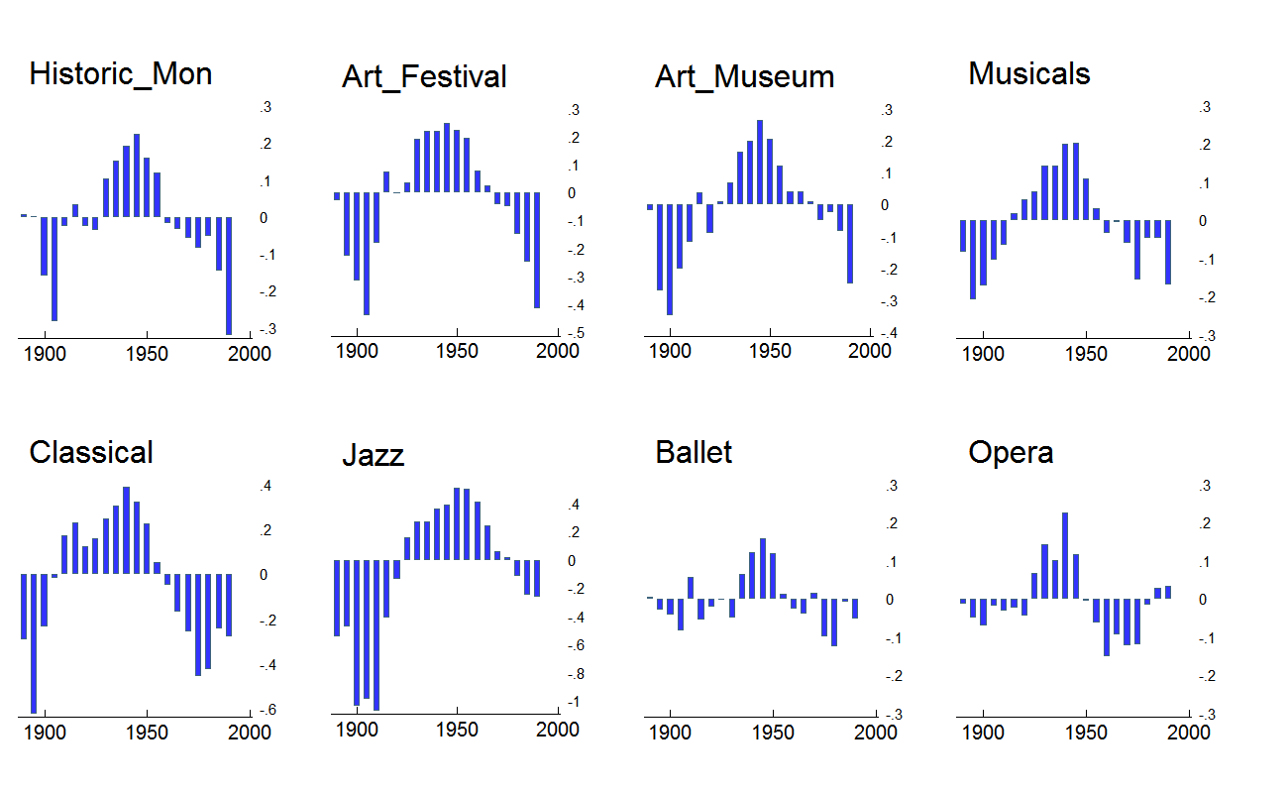Figure 1. Area chart of age and period-adjusted effects of cohort-group membership on arts participation for the eight core SPPA activities.

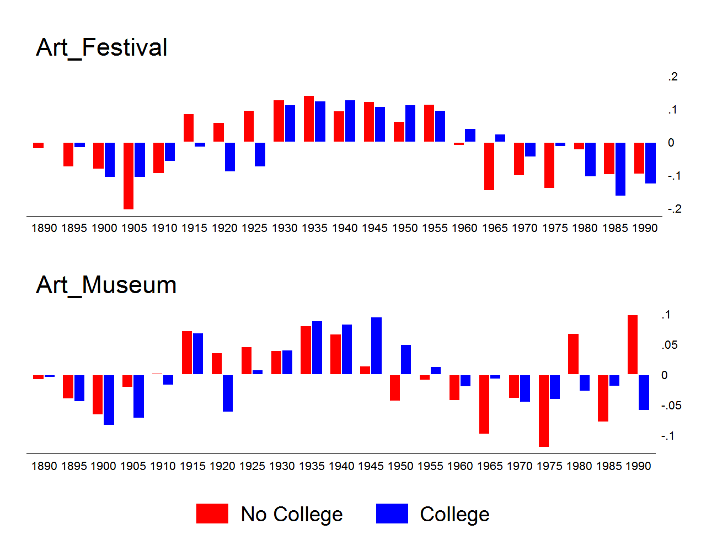
Figure 2 and 3. Bar chart of normalized cohort effect (θ_{j}) on Art Festivals/Craft Fairs (top panel) and Art Museums (bottom panel) participation for college and non-college educated respondents, 1982-2012 SPPA.

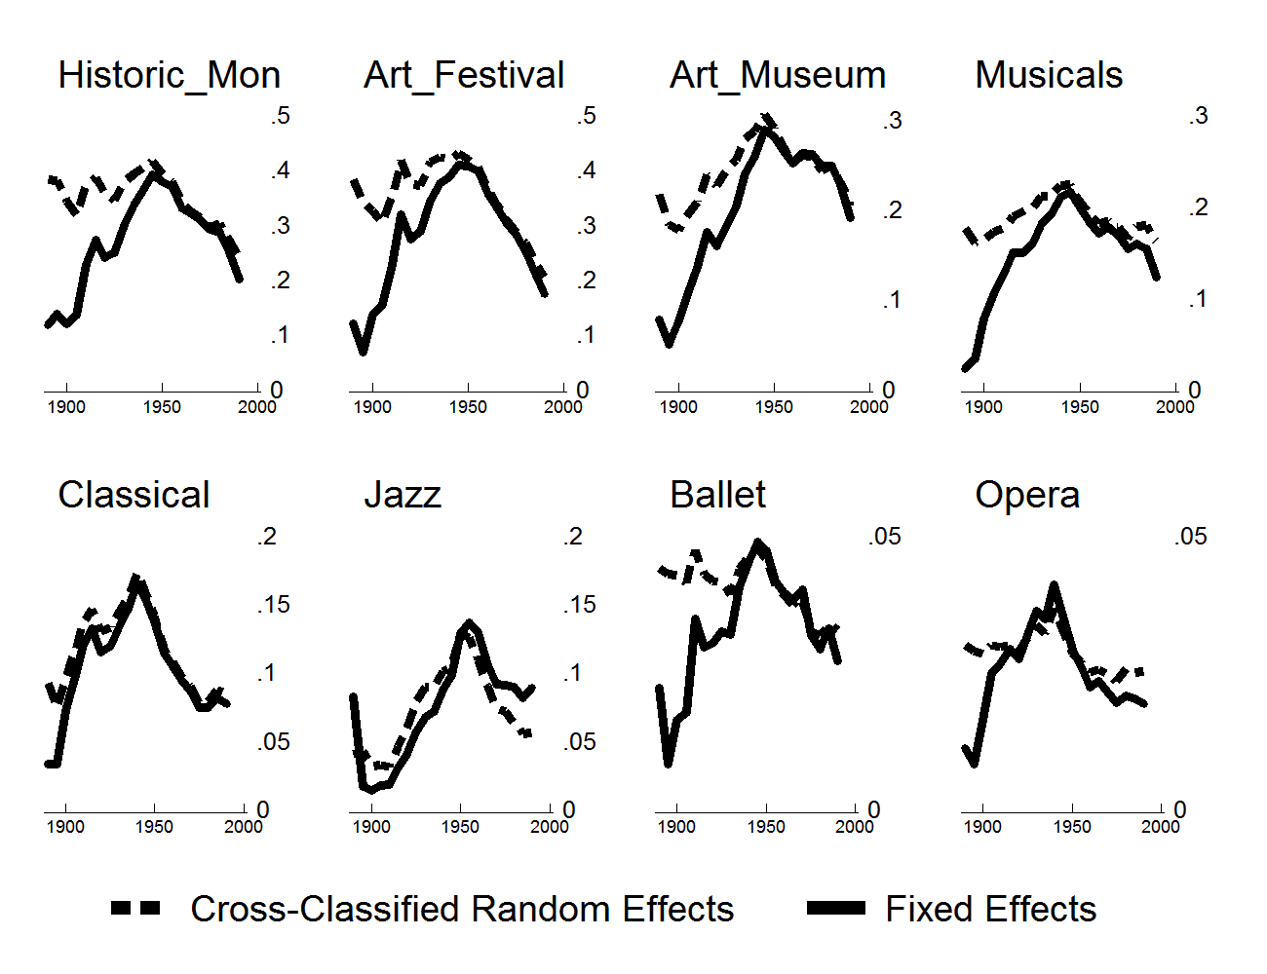
Figure 4. Line plots comparing predicted cohort trends in arts participation from cross-classified random-effects and fixed effects HAPC models. Panels ordered (from top left to bottom right) according to overall popularity of activity.

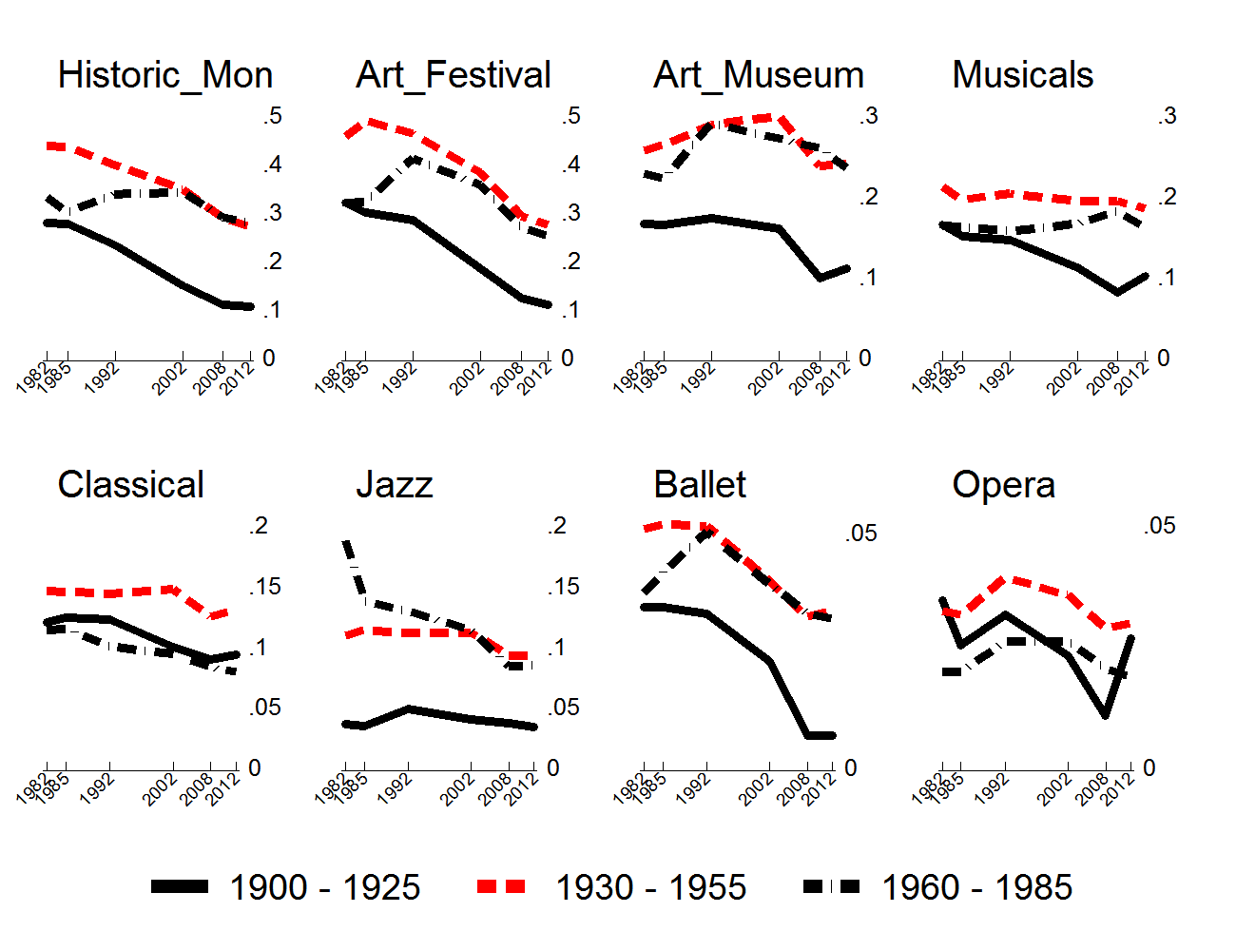
Figure 5. Graphical plot of arts participation frequency by survey year and HAPC-derived cohort group categories, 1982-2012 SPPA. Panels ordered (from top left to bottom right) according to overall popularity of activity.

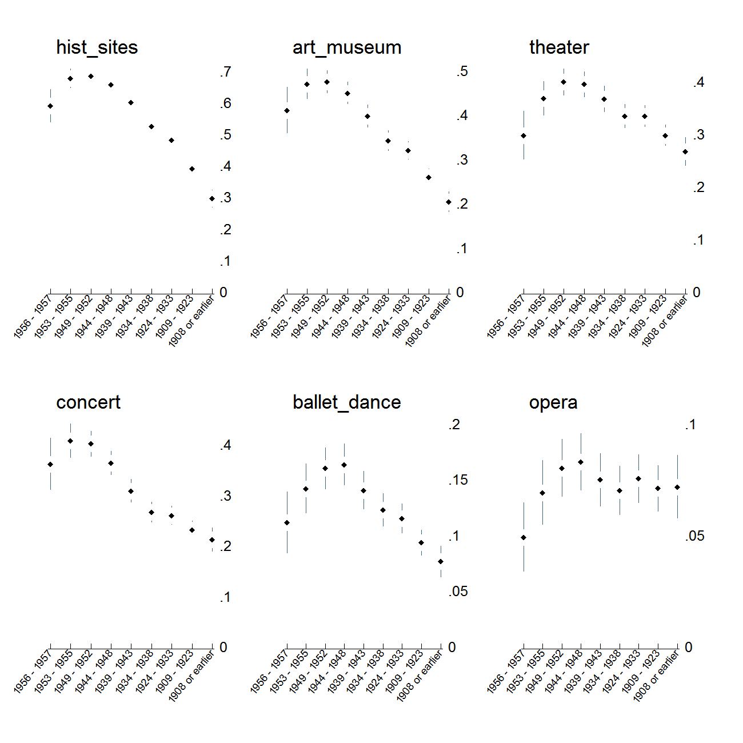
Figure 6. Predicted probability of exposure to the arts while growing up for members of different cohorts. Estimate are obtained from ordered logit models predicting having been exposed to the arts “often,” “sometimes,” “hardly ever,” or “never.” Plots show the additive probabilities of the first two responses adjusted for respondent's race, education, gender, and region of residence. Cohort effects are specified using both a linear and a quadratic term. Panels ordered (from top left to bottom right) according to overall popularity of activity.

For a more elaborate outline of the analytical advantages of this mixed methods approach see Spillman (2014); for an application to the study of taste see Fishman and Lizardo (2013).
For ease, we will refer to this as “folk culture” or “folk art” throughout the paper. As we will make clear below our interest lies in a field of fuzzy categorical distinctions comprised of a great variety of objects, ideas, people, and organizations. Scholars studying other fields have found that the artistic process unfolds over many decades (cf. Baumann 2001; Bourdieu 1993; Crane 1989; DiMaggio 1982, 1991, 2000; Ferguson 1998; Lena 2012; Lopes 2002) and often involves the collapse and exclusion of multiple proximal categories. In this case, those include stylistic categories like “Americana” and “vernacular modernism” (Wendy Griswold, personal correspondence, 10/1/15).
We follow the theoretical premise of research on generations inspired by the work of Mannheim (1952) in conceiving of the “coming of age” process generative of distinct cohorts as happening between the ages of 17 and 25 (Schuman and Rieger 1992: 315).
We estimate the CCRM models via maximum likelihood using the routine for multilevel logit regression modelling (xtmelogit) included in Stata 13.
In additional analyses (available upon request) of other arts participation items, we see that Art Festivals and Craft Fairs resemble more racially diverse forms of art participation including Jazz. While we observe strong generational effects for Whites when it comes to attendance at Classical Music (symphony) and Jazz Concerts, the generational effect for Blacks is much stronger for Jazz concerts and it begins much earlier than for Whites.
Gale Cengage Learning Archives Unbound. 2014. “Literature, Culture and Society in Depression Era America: Archives of the Federal Writers’ Project.” Retrieved March 24, 2014. (http://go.galegroup.com/gdsc/i.do?action=interpret&id=3TQA&v=2.1&u=columbiau&it=aboutCollections&p=GDSC&sw=w&authCount=1).
National Endowment for the Arts. Survey of Public Participation in the Arts 1982-2012 Combined File [United States]. ICPSR35596-v1. Ann Arbor, MI: Inter-university Consortium for Political and Social Research [distributor], 2014-12-22. http://doi.org/10.3886/ICPSR35596.v1 (Last accesssed 5/25/15).
Biddle’s letter to the President in May was followed in December, 1933 by the initiation of the Public Works of Art Project, after his proposal for a mural program was rejected by the Fine Arts Commission. He subsequently generated the support of several influential members of the administration including Edward Bruce, a Treasury Department employee and advocate for the arts (McDonald 1969: 357-359).
Over the course of the program, “total employment reached 3,749 persons. Works ranging from sculpture, murals, oils, and mosaics to craft articles, Navajo blankets, portraits, and stage sets, totaling in all 15,663 pieces, were completed. The total cost of the project was $1,312,000, of which 90.3 per cent went in wages to the artists themselves” (McDonald 1969: 62). Projects that were unfinished when PWAP was disbanded in 1934 received ongoing support from the Emergency Work Relief Program of FERA. Art works that were federal property were dispersed to public and nonprofit institutions until July, 1935.
Congress repeatedly attacked federal arts divisions based on reports of inefficiency and fraud. The Federal Theater project was abolished by Congress in 1939, charged with inefficiency, immorality, and infiltration by Communist agitators (N.A. 1939, “Relief: Hot Pan”). The other programs limped forward into the war years, when they were abandoned.
The output and impact of the Federal One projects may, in fact, pale in comparison to the achievements of many state and local relief administrations. New York’s was first among these, “almost unique in its progressive attitude,” and with significant reach: one accounting estimates that 12,000 people came to see a performance of Uncle Tom’s Cabin in Crotona Park (McDonald 1969: 70).
Over the nearly four years in which Federal One programs were in operation, the theater and music divisions (and their state sponsors) the were most successful in generating revenue through admission ticket sales. According to McDonald (1969: 288), the theater division generated $2.1 million in revenue, while the music division ticket sales yielded $488,618 and change.
The emphasis on nationalism in art finds many earlier expressions, the most proximate of which was the turn of artists’ organizations in the 1920s toward such language. The American Artists’ Professional League adopted the slogan ‘I am for American Art,” while the American Artists Guild and the Society of Illustrators commanded the government to commission official portraits of officials from native artists, and the American Federation of Artists encouraged communities to support local artists (McDonald 1969: 346).
These are obtained by estimating the Best Linear Unbiased predictors from the variance component estimates for each 5-year cohort group and each survey wave (Rabe-Hesketh and Skrondal 2008: 489).
The 1982 survey holds data from 17,254 U.S. households, the 1985 survey contains information on 13,675 households, the 1992 survey pertains to 12,736 households, and the 2002 survey contains 17,135 households, the 2008 survey includes 18,444 households, and the 2012 survey has a sample size of 18,051 households, for a cumulative sample size of 97,295.
Exact response rates for the 1973 survey are not available; for more technical details on the American and the Arts survey series, see: http://www.icpsr.umich.edu/icpsrweb/NADAC/studies/35575?archive=NADAC&q=american+and+the+arts#method
Note that in most cases, exposure rates drop for persons born in the second half of the 1950s, which is consistent with the generational boundaries delimiting the omnivorous generation from their successors in the results obtained from SPPA data. We would not read too much into these results as these individuals were between 16-17 years old at the time of the interview.
Data files were obtained from the National Archive of Data on Arts & Culture (NADAC) hosted by ICPSR at: http://www.icpsr.umich.edu/icpsrweb/NADAC/.
In other analyses (available upon request) we have examined variation of generational and period effects on the SPPA core participation items by gender, and race by fitting group specific HAPC models to the data.
Whether the result first reported by Peterson and Kern (1996) could be considered a cohort, period, or age effect is not clear as they did not subject the data to an estimation procedure capable of teasing out the effects of these factors.
Our argument is agnostic as to whether these relatively recent epochal transformations have brought a permanent shift in the way that individuals engage the arts because we do not investigate individual-level traits. Absent more powerful sources of evidence, our suspicion is that the epochal argument may underestimate the historical continuities (and synchronic discontinuities) produced by the capacity of individual to carry history forward into the present (Abbott 2016).

